**Exercise 1**

Question 1

***Aim:*** Create a web page having 9 images arranged in 3*3 matrixes. When a user clicks on any image, it should open in a new tab.

***Code:***

**Images.html**

<!DOCTYPE html>

<html>

    <head>

        <title>Aashita Goyal (1913541) Exercise Q1</title>

    </head>

    <body>

        <table>

            <tr>

                <td><a href="images/1.jpg" target = _blank ><img src="images/1.jpg" alt = "Image 1" height=170 width=275 border="6" /></a></td>

                <td><a href="images/3.jpg" target = _blank ><img src="images/3.jpg" alt = "Image 3" height=170 width=275 border="6" /></a></td>

                <td><a href="images/5.jpg" target = _blank ><img src="images/5.jpg" alt = "Image 5" height=170 width=275 border="6" /></a></td>

            </tr>

            <tr>

                <td><a href="images/7.jpg" target = _blank ><img src="images/7.jpg" alt = "Image 7" height=170 width=275 border="6" /></a></td>

                <td><a href="images/9.jpg" target = _blank ><img src="images/9.jpg" alt = "Image 9" height=170 width=275 border="6" /></a></td>

                <td><a href="images/11.jpg" target = _blank ><img src="images/11.jpg" alt = "Image 11" height=170 width=275 border="6" /></a></td>

            </tr>

            <tr>

                <td><a href="images/13.jpg" target = _blank ><img src="images/13.jpg" alt = "Image 13" height=170 width=275 border="6" /></a></td>

                <td><a href="images/15.jpg" target = _blank ><img src="images/15.jpg" alt = "Image 15" height=170 width=275 border="6" /></a></td>

                <td><a href="images/17.jpg" target = _blank ><img src="images/17.jpg" alt = "Image 17" height=170 width=275 border="6" /></a></td>

            </tr>

        </table>

    </body>

</html>

***Output:***

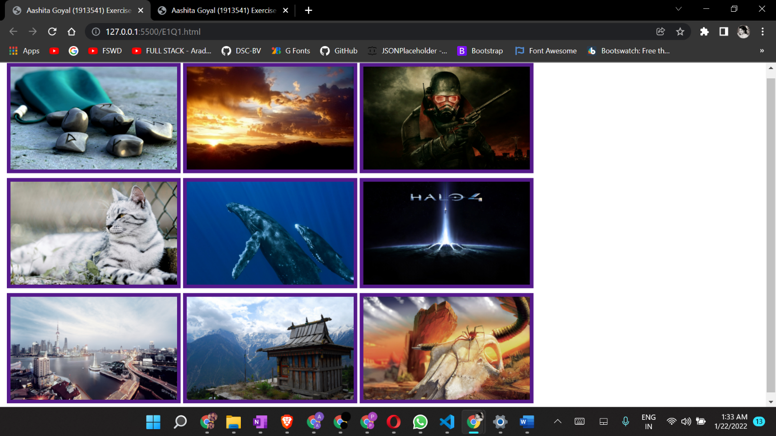

Question 2

***Aim:*** Create a web page that displays image thumbnails of 4 images. Also arrange all these images in one after another in same webpage covering 100% width of webpage. When a user clicks on thumbnail it should display corresponding image to user. (You have to create only one page).

***Code:***

**Thumbnails.html**

<!DOCTYPE html>

<html>

    <head>

        <title>Aashita Goyal (1913541) Exercise Q2</title>

    </head>

    <body bgcolor="black" >

        <a href="#2"><img src = "images/2.jpg"  alt= "Image 2" height="80" ></a>

        <a href="#4"><img src = "images/4.jpg"  alt= "Image 4" height="80" ></a>

        <a href="#6"><img src = "images/6.jpg"  alt= "Image 6" height="80" ></a>

        <a href="#8"><img src = "images/8.jpg"  alt= "Image 8" height="80" ></a>

        <br><br><hr>

        <img id="2" src = "images/2.jpg"  alt= "Image 2" height=550 width=100% >

        <hr>

        <img id="4" src = "images/4.jpg"  alt= "Image 4" height=550 width=100% >

        <hr>

        <img id="6" src = "images/6.jpg"  alt= "Image 6" height=550 width=100% >

        <hr>

        <img id="8" src = "images/8.jpg"  alt= "Image 8" height=550 width=100% >

        <hr>

    </body>

</html>

***Output:***

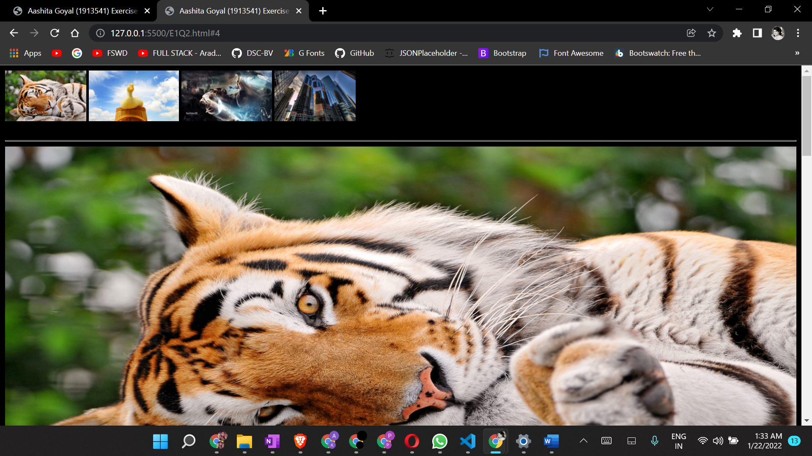

**Exercise 2**

Question 3

***Aim:*** Create a user feedback page which asks questions about a software product. You are required to use checkbox, radio buttons, and drop-down, text area and various text input type for this. Structure the web page using HTML table.

***Code:***

**Feedback.html**

<!DOCTYPE html>

<html>

    <head>

        <title> Feedback form</title>

    </head>

    <body bgcolor="black">

        <table border=0 bgcolor="#e3dede" align="center">

            <form method = "post" action = "forms.html">

                <h3 align="center"><b><font color="white">Software feedback form</font></b></h3>

                <tr>

                    <td>

                        <label> Name </label>

                    </td>

                    <td>

                        <input type = "text" name = "Name" size=54 placeholder="Enter Your Name here" />

                    </td>

                </tr>

                <tr>

                    <td>

                        <label> Email </label>

                    </td>

                    <td>

                        <input type = "text" name = "email" size=54 placeholder="Enter Your Email here" />

                    </td>

                </tr>

                <tr>

                    <td>

                        <label> Gender  </label>

                    </td>

                    <td>

                        <input type = "radio" name = "gender" value ="male" /><label> Male </label>

                        <input type = "radio" name = "gender" value ="female" /><label> Female </label>

                    </td>

                </tr>

                <tr>

                    <td>

                        <label> What do you do? </label>

                    </td>

                    <td>

                        <select name = "class">

                            <option value = "Professional"> Student </option>

                            <option value = "Student"> Working Professional </option>

                        </select>

                    </td>

                </tr>

                <tr>

                    <td>

                        <label> How satisfied were<br> you with our product? </label>

                    </td>

                    <td>

                        <label for=min id=min> 0 </label>

                        <input type=range name="scale" min=0 max=10 />

                        <label for=max> 10</label>

                    </td>

                </tr>

                <tr>

                    <td>

                        <label> Remarks </label>

                    </td>

                    <td>

    <textarea name = "comment" rows=5 cols=50 placeholder="Remarks" ></textarea>

                    </td>

                </tr>

                <tr>

                    <td>

                        <label> How would you like<br> to receive updates? </label>

                    </td>

                    <td>

                        <input type="checkbox" id="email" name="email">

                        <label for="email"> Through Email</label><br>

                        <input type="checkbox" id="phone" name="phone">

                        <label for="phone"> Through Phone Number</label>

                    </td>

                </tr>

                <br>

                <tr>

                    <td colspan=2 align="center">

                        <input type = "reset" name = "reset" value= "reset" />

                        <input type = "submit" name = "submit" value = "submit" /><br>

                    </td>

                </tr>

            </form>

        </table>

    </body>

</html>

***Code:***

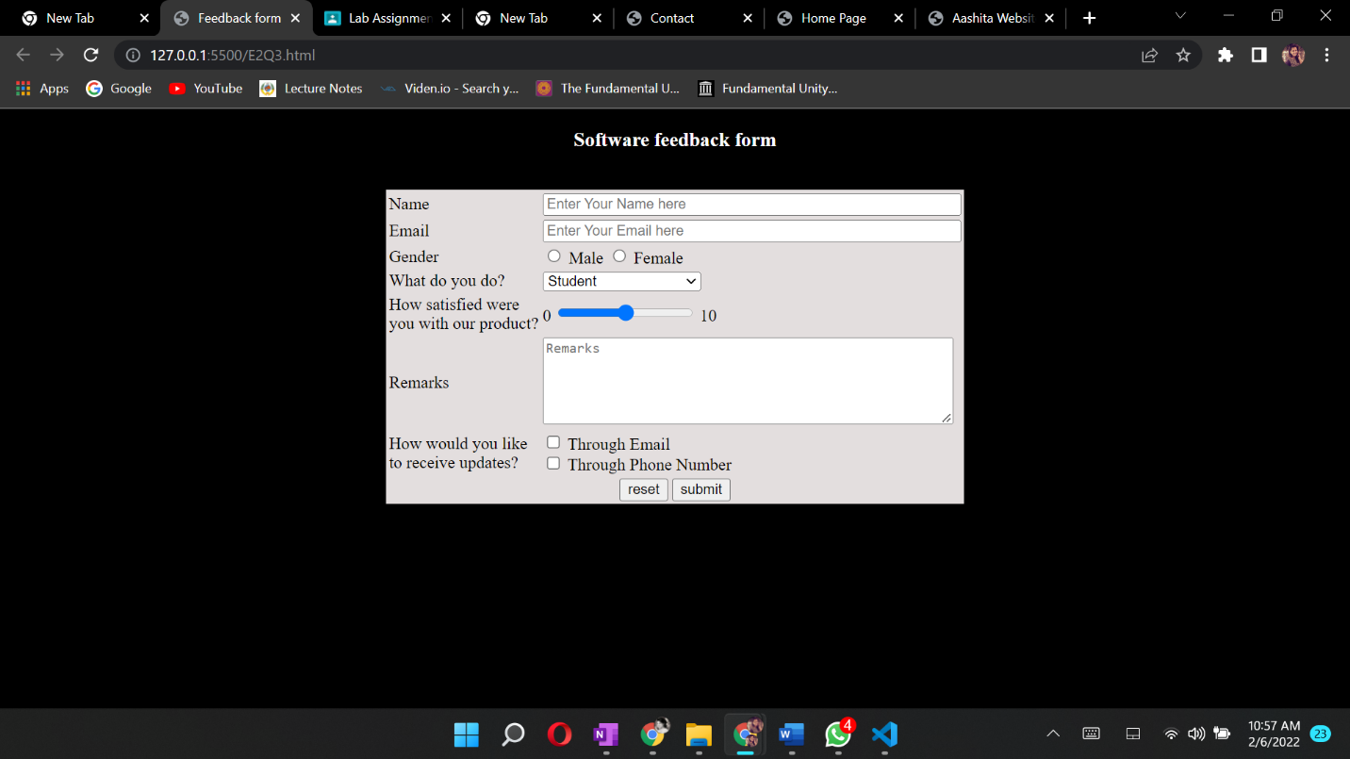

Question 4

***Aim:*** Create a home page for personal website with 4 sections Header, Navigation bar (menu bar), content and footer section. It should have a menu bar for “Bio-Data, Contact, Photo, Video, Notes etc.” For each menu option create a separate web page and link with home page. Structure the web page using HTML table.

***Code:***

**Home.html**

<html>

    <head>

        <title>Home Page</title>

    </head>

    <body bgcolor = "black" text="white">

        <header>

        <table  cellpadding = "8" >

        <tr colspan = 2>

            <nav position = "fixed" top = 0  >

            <td rowspan = 2><a  href = "BioData.html"><b>PersonalDetails</b></a></td>

            <td rowspan = 2><a href = "contact.html"><b>Contact</b></a></td>

            <td rowspan = 2><a href = "videos.html"><b>Videos</b></a></td>

            <td rowspan = 2><a href = "photos.html"><b>Photos</b></a></td>

            <td rowspan = 2><a href = "notes.html"><b>Notes</b></a></td>

            </nav>

            </tr>

            </table>

        </header>

    <div style = "font-size:18px">

    <p>Hello, I am Aashita Goyal</p>

    <p>This is my Introduction page with my basic details, Bio Data, Contact Details, some videos, some photos and some notes.</p>

    <p>In the personal details, I shared all the details you need to know about me.</p>

    <p>In contact section, I have provided all possible contact details.</p>

    <p>Videos section contains some fun videos :)</p>

    <p>In the image section, I have shown some beautiful scenic pictures.</p>

    <p>In the notes section, I have listed some of my basic understanding of web development.</p>

    </div>

    </body>

</html>

**BioData.html**

<html>

<head>

    <title>Personal Details</title>

</head>

<body>

    <header align = "centre">

        <h1>Basic Information</h1>

    <header>

    <hr>

    <table width = "800" border = "0" align = "centre" cellpadding = "5" style=font-size:20px >

    <tr>

    <td align = "right" font-size = 10px><b><label>Name : </label></b></td>

    <b><td >Aashita Goyal<td></b>

    </tr>

    <tr>

    <td align = "right"><b><label>Gender : </label></b></td>

    <b><td >Female<td></b>

    </tr>

    <tr>

    <td align = "right"><b><label>D.O.B : </label></b></td>

    <b><td >10 June 2001<td></b>

    </tr>

    <tr>

    <td align = "right"><b><label>Father's Name : </label></b></td>

    <b><td >Sumeet Goyal<td></b>

    </tr>

    <tr>

    <td align = "right"><b><label>Mother's Name : </label></b></td>

    <b><td >Rekha Goyal<td></b>

    </tr>

    <tr>

    <td align = "right"><b><label>Religion : </label></b></td>

    <b><td >Hindu<td></b>

    </tr>

    </table>

</body>

</html>

**contact.html**

<html>

<head>

    <title>Contact</title>

</head>

<body>

    <header align = "centre">

        <b><h1>Contact Details</h1></b>

    <header>

    <hr>

    <body>

    <table width = "800" cellpadding = "5" align = "centre" style=font-size:20px>

    <tr>

    <td align = "right" valign = "top"><b><label>Address : </label></b></td>

    <td>Sector 10<br>R K Puram<br>New Delhi<td>

    </tr>

    <tr>

    <td align = "right" valign = "top"><b><label>Phone no. : </label></b></td>

    <td>(+91)9464908884<br>(+91)9958379725<td>

    </tr>

    <tr>

    <td align = "right"><b><label>Email Address : </label></b></td>

    <td>aashitagoyal99@gmail.com<td>

    </tr>

    </table>

    </body>

    </html>

**photos.html**

<!DOCTYPE html>

<html>

<head>

    <title>Beautiful sights</title>

</head>

<body>

<header>

<h1>Beautiful sights</h1>

<hr>

</header>

    <TABLE>

        <tr>

        <img src = "8.jpg" alt = "beautiful pic" width = "1000px">

        </tr>

        <tr align = "right">

        <img src = "9.jpg" alt = "beautiful pic" width = "1000px">

        </tr>

        <tr>

        <img src = "10.jpg" alt = "beautiful pic" width = "1000px">

        </tr>

    </TABLE>

</body>

</html>

**videos.html**

<!DOCTYPE html>

<html>

<head>

    <title>Videos Page</title>

</head>

<body>

    <header>

        <h1>Videos</h1>

    <header>

    <table align = "centre">

    <tr >

    <video  height = 400 width = 800 controls>

    <source src = "first.mp4" type = "video/mp4">

    Browse doesn't support this video

    </video>

    </tr>

<br>

<tr>

    <video  height = 400 width = 800 controls>

    <source src = "second.mp4" type = "video/mp4">

    Browse doesn't support this video

    </video>

    </tr>

    <br>

    </table>

</body>

</html>

**notes.html**

<!DOCTYPE html>

<html>

<head>

    <title>Notes</title>

</head>

<body>

    <header align = "centre">

        <h1>Notes</h1>

    <header>

<p>DNS - Domain Name System

    Browser sends url text to DNS server

    DNS server converts the text into IP address

    This IP address is understood by the computer (application server)  and the specific browser window is opened

    The url text is entered by the user i.e. us</p>

<br>

<p>HTTPS - Hyper Text Transfer Protocol Secure

    Protocol - is an instruction. It instructs the specific HTML, CSS and JavaScript files that need to be accessed for the particular browser window

    Domain - is a unique identification or a license, provided to an application. It is bought.

    Sub Domain - is like a child of the main domain. It can be bought separately, or connected with the main domain

    Top Level Domain (TLD) is one of the categories that DNS uses to securely arrange the websites available in that domain

    .com .in .co are all TLD

    Path defines the HTML file address

    Anchor is used to display a particular content in HTML file

    Instead of reading the HTML file from beginning, anchor helps us access the part of the file that we want to.

    Web development - Planning, Deployment and uploading it on cloud is known as web development

    Static - The content of websites should not change

    Dynamic - The contents of websites change in dynamic

    How does the server read our HTML files?

    When a browser requests a server, the serve responds with the HTML, CSS and JavaScript files required.

        1. DOM - Document Object Model. It is hierarchial.

    It is not written one below the other.It is written in an hierarchial manner so that all parent and child tags can be accessed.

        2. CSSOM - Cascading Style Sheet Object Model. (similar to DOM, but this is for CSS where DOM is for HTML)

    Render Tree -  Combined DOM and CSSOM is known as render tree. It is responsible for showing our websites in our browser</p>

**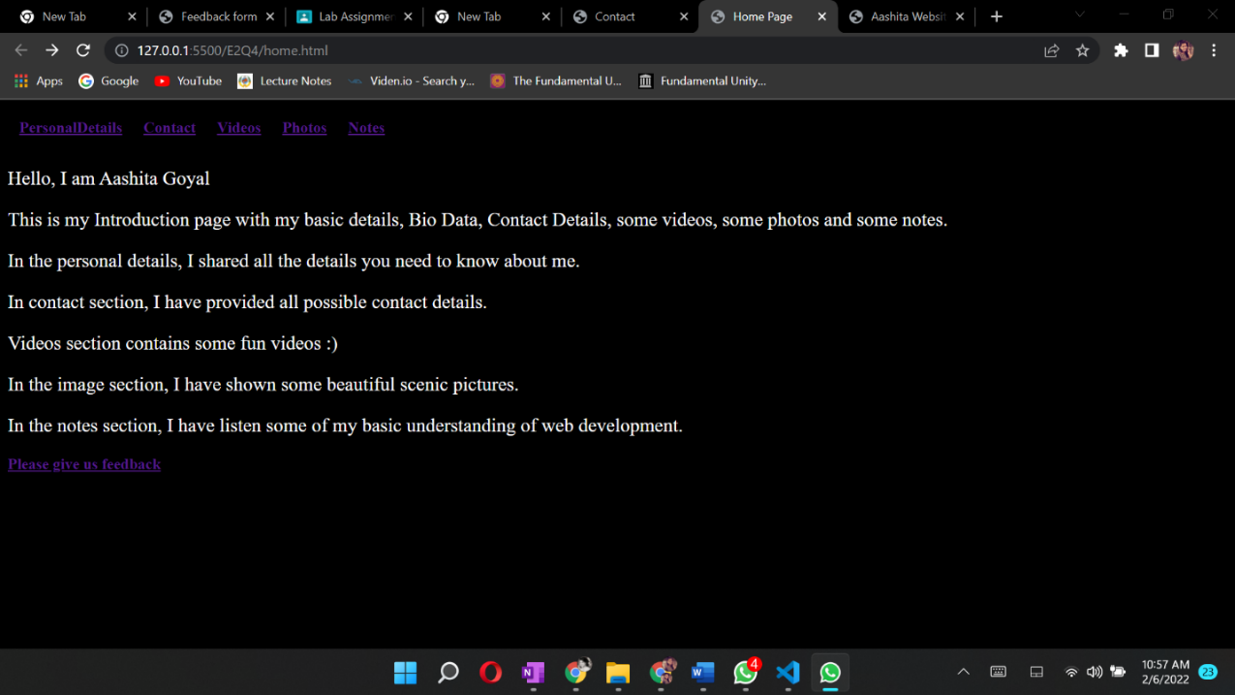*Output:***

**Exercise 3**

Question 5

***Aim:*** Write an external style sheet to format the Internet.html document as attached to apply

following effects: -  
  
                    1. Put a background color and image with gradient overlay.  
                    2. Make h1 heading 30px, bolder, use color according to your background.  
                    3. Paragraphs should have font size 15px and choose color according to background.  
                    4. Increase line spacing in paragraph text.  
                    5. Highlight important words and use styling for that.  
                    6. Make h2 heading 20px and choose color according to background.

***Code:***

**Internet.html**

<!DOCTYPE html>

<html>

  <head>

    <title>Aashita Goyal (1913541) Exercise3-Q5</title>

    <link rel="stylesheet" href="Internet.css" />

  </head>

  <body>

    <div class="heading1"><h1>&nbsp;INTERNET</h1></div>

    <br />

    <div class="para">

      <p>

        The

        <strong><u>Internet</u></strong>

        , sometimes called simply "

        <strong><u>the Net</u></strong>

        ," is a worldwide system of computer networks -- a network of networks

        in which users at any one computer can, if they have permission, get

        information from any other computer (and sometimes talk directly to

        users at other computers). It was conceived by the Advanced Research

        Projects Agency (ARPA) of the U.S. government in 1969 and was first

        known as the

        <strong><u>ARPANet</u></strong>

        . The original aim was to create a network that would allow users of a

        research computer at one university to "talk to" research computers at

        other universities. A side benefit of ARPANet's design was that, because

        messages could be routed or rerouted in more than one direction, the

        network could continue to function even if parts of it were destroyed in

        the event of a military attack or other disaster.

      </p>

      <p>

        &nbsp; &nbsp; &nbsp; &nbsp; &nbsp; &nbsp; &nbsp; Today, the Internet is

        a public, cooperative and self-sustaining facility accessible to

        hundreds of millions of people worldwide. It is used by many as the

        primary source of information consumption, and fueled the creation and

        growth of its own social ecosystem through social media and content

        sharing. Furthermore, e-commerce, or online shopping, has become one of

        the largest uses of the Internet.

      </p>

    </div>

    <br />

    <br />

    <br />

    <br />

    <br />

    <div class="heading2"><h2>&nbsp; How the Internet works</h2></div>

    <div class="para">

      <p>

        <br />

        Physically, the Internet uses a portion of the total resources of the

        currently existing public telecommunication networks. Technically, what

        distinguishes the Internet is its use of a set of protocols called

        Transmission Control Protocol/Internet Protocol (TCP/IP). Two recent

        adaptations of Internet technology, the intranet and the extranet, also

        make use of the

        <strong><u>TCP/IP</u></strong>

        protocol.

      </p>

      <p>

        &nbsp; &nbsp; &nbsp; &nbsp; &nbsp; &nbsp; &nbsp;The Internet can be seen

        as having two major components: network protocols and hardware. The

        protocols, such as the TCP/IP suite, present sets of rules that devices

        must follow in order to complete tasks. Without this common collection

        of rules, machines would not be able to communicate.

      </p>

    </div>

  </body>

</html>

**Internet.css**

* {

  margin: 0;

  padding: 0;

  box-sizing: border-box;

}

body {

  background-image: linear-gradient(

      to bottom,

      rgba(33, 159, 148, 0.52),

      rgba(232, 232, 166, 0.73)

    ),

    url('../images/img1.jpg');

  width: 80%;

  height: 400px;

  background-size: cover;

  color: white;

  padding: 20px;

}

h1 {

  font-size: 30px;

  font-style: bolder;

  font-weight: bolder;

  color: #19765d;

  font-family: 'Franklin Gothic Medium', 'Arial Narrow', Arial, sans-serif;

}

p {

  font-size: 15px;

  font-weight: 500;

  font-family: 'Lucida Sans', 'Lucida Sans Regular', 'Lucida Grande',

    'Lucida Sans Unicode', Geneva, Verdana, sans-serif;

}

h2 {

  font-size: 20px;

  /*  color: #646E21; */

  color: #e5fd46;

  font-weight: bolder;

  font-family: 'Franklin Gothic Medium', 'Arial Narrow', Arial, sans-serif;

}

strong {

  color: black;

  font-weight: 500;

}

.heading1 {

  border-style: groove;

  width: 150px;

  background-image: linear-gradient(

    to right,

    rgba(33, 159, 148, 0.52),

    rgba(232, 232, 166, 0.73)

  );

}

.heading2 {

  border-style: groove;

  box-shadow: #19765d;

  width: 220px;

}

.para {

  border-color: black;

  border-width: 10px;

}

***Output:***

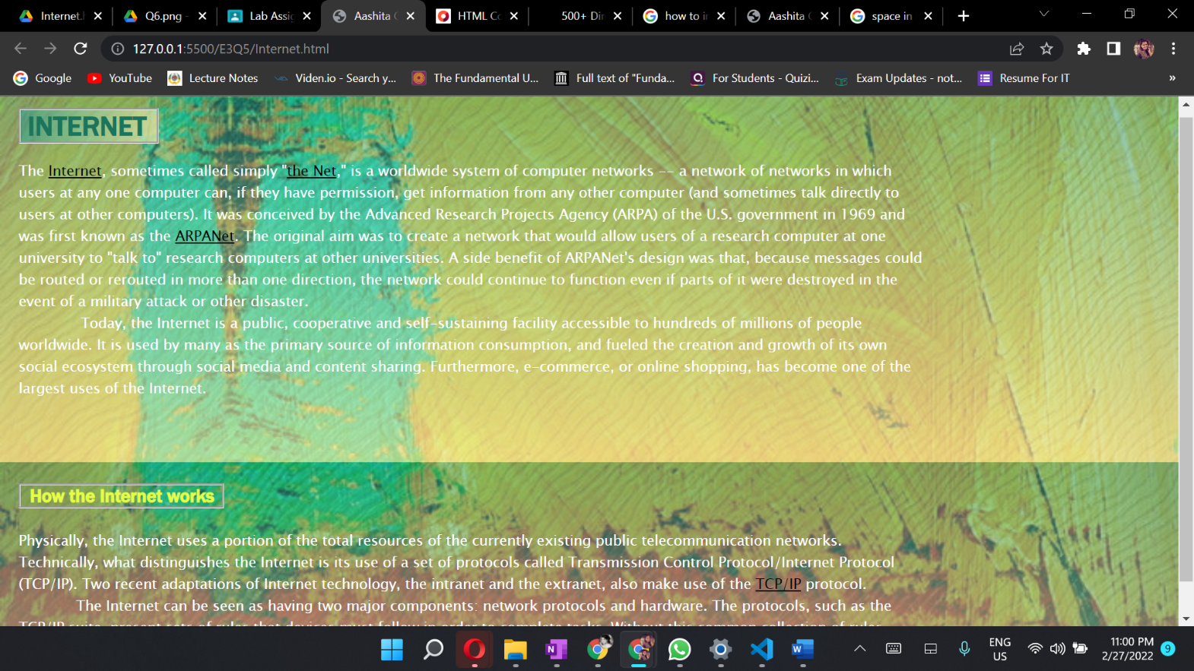

Question 6

***Aim:*** Create a webpage that displays your favorite quotations in a web page just above images.

You have to use border, height, width, margin, padding, outline properties of CSS.  
          Also use text and font properties to add effects in text to display quotations.

***Code:***

**Quotes.html**

<!DOCTYPE html>

    <html>

        <head>

            <title>Aashita Goyal (1913541) Exercise3-Q6</title>

            <link rel="stylesheet" href="Quotes.css">

        </head>

        <body>

            <section class="quote__container">

                <div><h1 class="quote__text">Quotes</h1></div>

                <div class="quote__images__container">

                    <div class="quote__images__row__one">

                        <br>

                        <div class="quote__image__1">

                            <div class="quote__1">

                                <br>

                                <div class="quote__first">

                                    <br>

                                        <p>

                                            Your last choice <br>

                                              is God's first.

                                        </p>

                                </div>

                            </div>

                        </div>

                        <div class="quote__image__2">

                            <div class="quote__2">

                                <div class="quote__second">

                                        <p>

                                            Success is the sum of

                                            small efforts,<br>

                                            Repeated day in and

                                            day out

                                        </p>

                                </div>

                            </div>

                        </div>

                    </div>

                    <div class="quote__images__row__two">

                        <div class="quote__image__3">

                            <br><br>

                            <div class="quote__3">

                                <div class="quote__third">

                                        <p>

                                            Whether you think you <br>

                                            can, or think you can't <br>

                                            you are always right

                                        </p>

                                </div>

                            </div>

                        </div>

                        <div class="quote__image__4">

                            <div class="quote__4">

                                <div class="quote__fourth">

                                        <p>

                                            The only constant <br>

                                            is change

                                        </p>

                                </div>

                            </div>

                        </div>

                    </div>

                </div>

            </section>

            <br><br><br>

        </body>

    </html>

**Quotes.css**

body{

    background-image:

    linear-gradient(to right,  rgba(34, 34, 53, 0), rgba(220, 202, 45, 0.92)),

    url('../images/bgs/black_paper.png');

}

.quote__container{

    width: 100%;

    padding: 50px 0;

    display: flex;

}

.quote__text{

    padding: 12px 0;

    font-family: 'Source Sans Pro', sans-serif;

    font-size: 53px;

    padding-left: 40px;

}

.quote__images__container{

    width: 65%;

    padding-left: 300px;

}

.quote__images__row__one,

.quote__images__row__two{

    width: 100%;

    display: flex;

    gap: 3px;

}

.quote__images__row__one{

    align-items: baseline;

    margin-bottom: 3px;

}

    .quote__image__1,

    .quote__image__4{

        width: 150%;

        height: 190px;

    }

    .quote__image__2,

    .quote__image__3{

        width: 170%;

        height: 230px;

    }

    .quote__1,

    .quote__2,

    .quote__3,

    .quote__4{

        width: 100%;

        height: 100%;

    }

    .quote__1{

        background-image: url('../images/img9.jpg');

        border-radius: 10px;

        border-style: double;

        border-width: 10px;

       /* position: absolute;

        height: 180px;

        width: 377px;

        top: 30;

        bottom: 40;*/

    }

    .quote__2{

        background-image: url('../images/img10.jpg');

        padding-bottom: 0;

        border-radius: 10px;

        border-style: double;

        border-width: 10px;

        margin-left: 20px;

    }

    .quote__3{

        background-image: url('../images/img22.jpg');

        border-radius: 10px;

        border-style: double;

        border-width: 10px;

    }

    .quote__4{

        background-image: url('../images/img30.jpg');

        border-radius: 10px;

        border-style: double;

        border-width: 10px;

        margin-left: 20px;

    }

    .quote__first{

        color: white;

        padding-top: 30px;

        padding-left: 50px;

    }

    .quote__second{

        color: white;

        padding-left: 130px;

        padding-top: 70px;

    }

    .quote__third{

        color: white;

        padding-top: 25px;

        padding-left: 245px;

    }

    .quote__fourth{

        color: white;

        padding-top: 30px;

        padding-left: 70px;

    }

***Output:***

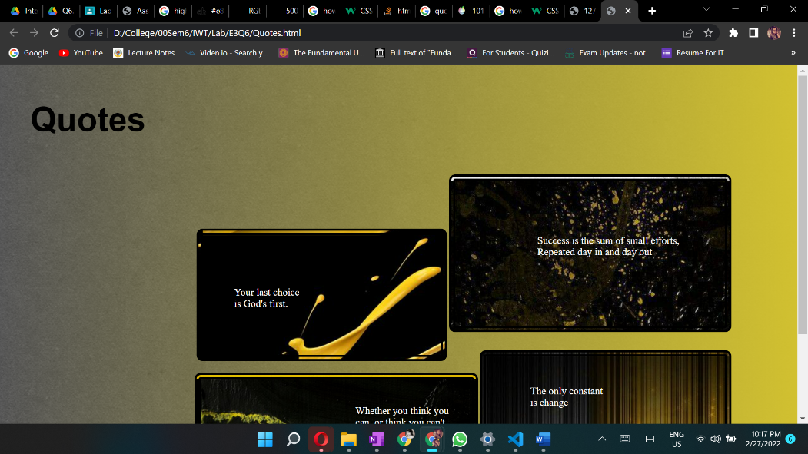

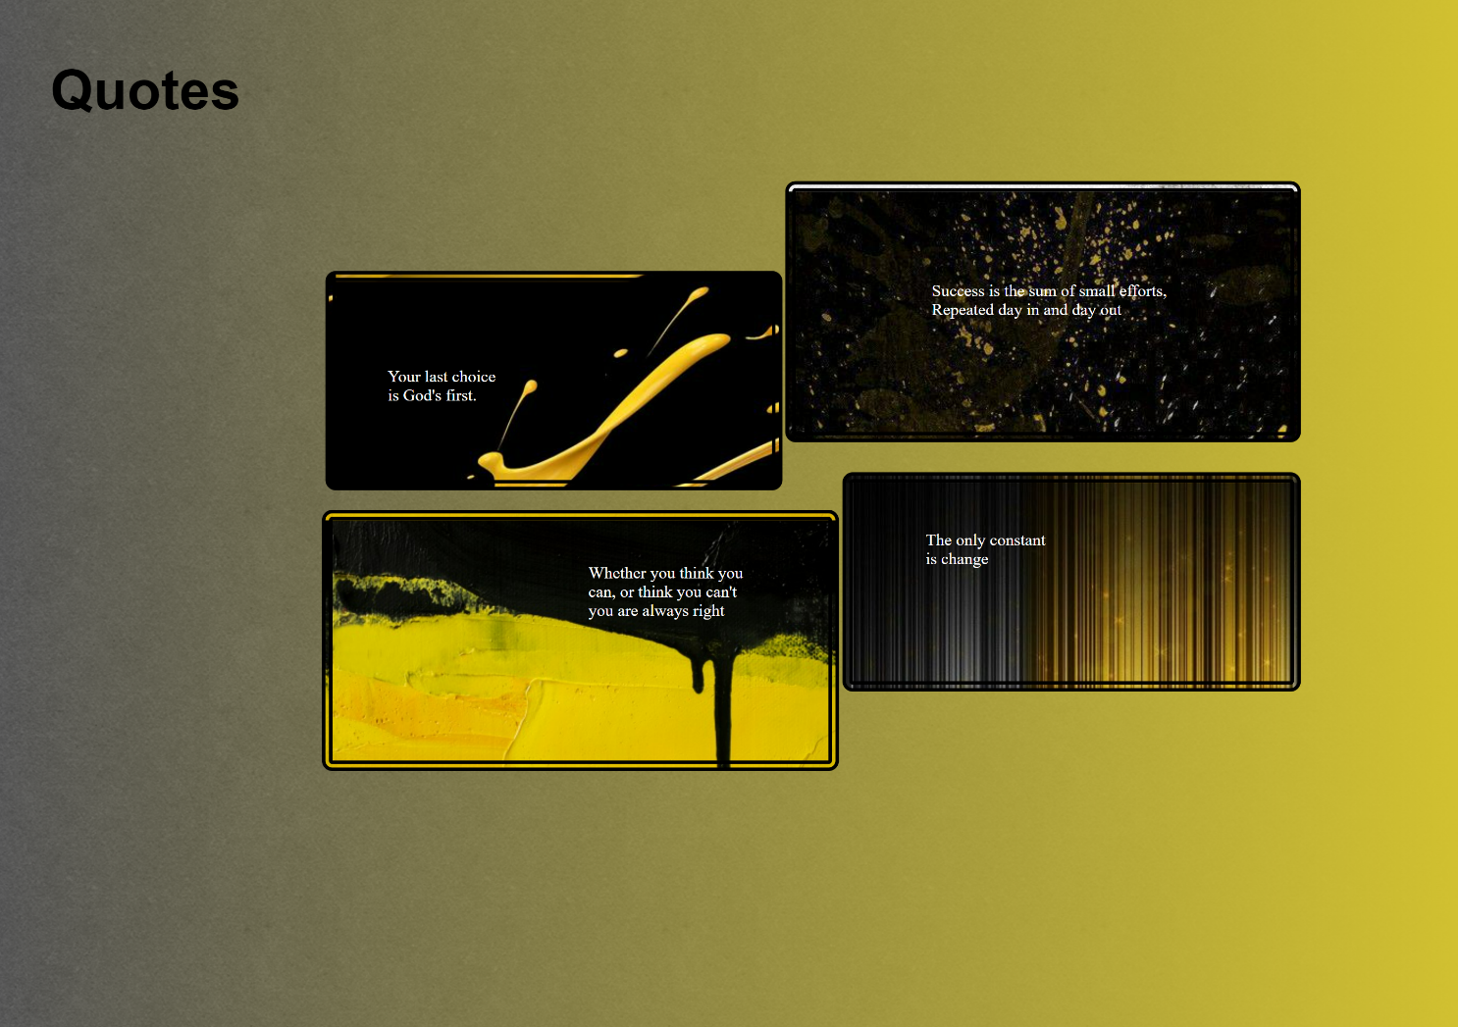***Full Page Screenshot:***

**Exercise 4**

Question 7

***Aim:*** Implement a one-page personal website to present your resume. Design of the webpage should be like given example.

<https://sachagreif.com/>  
  
Your webpage should also have a navigation menu.

***Code:***

**Portfolio.html**

<!DOCTYPE html>

<html>

    <head>

        <title>Aashita Goyal (1913541) Exercise 4 Q1</title>

        <link rel="stylesheet" href="Portfolio.css">

        <link rel="shortcut icon" type="image/x-icon" href="https://iconape.com/wp-content/png_logo_vector/ag-2.png" class="tab-logo" />

    </head>

    <body>

        <nav class="navbar" style="background-color: #655d8a" id="grad">

            <div class="container">

                <img class="logo" src="https://iconape.com/wp-content/png_logo_vector/ag-2.png" >

                   <div class="nav-content">

                        <a href="#section1" class="btn">Bio</a>

                        <a href="#section2" class="btn">Code</a>

                        <a href="#section3" class="btn">Projects</a>

                        <a href="#section4" class="btn">Writing</a>

                        <a href="#section2" class="btn">Podcasts</a>

                        <a href="#section3" class="btn">Graveyard</a>

                    </div>

            <div class="nav-index">

                <ul class="nav-icon">

                    <li class="nav-item">

                      <a class="nav-link" href="">Profile

                      <img src="https://img.icons8.com/glyph-neue/64/000000/lifecycle.png" class="icons"/>

                      </a>

                    </li>

                    <li class="nav-item">

                      <a class="nav-link" href="">Logout

                      <img src="https://img.icons8.com/ios/100/000000/shutdown--v1.png" class="icons"/>

                      </a>

                    </li>

                </ul>

            </div>

        </div>

    </nav>

    <div style="background-color: #EB613D;" >

        <form id="form" style="border-left: 30px solid white; ">

            <img src="https://iconape.com/wp-content/png_logo_vector/ag-2.png"

                 style="width:100px; height:100px;" />

            <p>I'm <b>Aashita Goyal</b>, a developer, a student and an aspirant.

            I'm from New Delhi, India.

            <span style="color: red;">Say hello</span>, or keep scrolling.

            </p>

            <br><br>

        <div class="social-media-logo-container">

            <div><p>---------------------------------</p></div>

            <div >

            <a href="https://sachagreif.com/"><img src=" https://www.nicepng.com/png/detail/4-40303_see-here-new-2018-twitter-logo-black-and.png" class="social-media-logo"></a>

            <a href="https://sachagreif.com/"><img src="https://img.favpng.com/4/20/21/github-computer-icons-icon-design-png-favpng-KaDTwuHWgG8D1qn47QW2hK7Gj.jpg" class="social-media-logo"></a>

            <a href="https://sachagreif.com/"><img src=" https://i.pinimg.com/236x/79/b9/80/79b9802cd78648e7a6644f3710cd3375.jpg" class="social-media-logo"></a>

            <a href="https://sachagreif.com/"><img src=" https://toppng.com/uploads/preview/black-round-instagram-logo-11549531861xqjnpo2dom.png" class="social-media-logo"></a>

            </div>

            <div><p>---------------------------------</p></div>

        </div>

           </form>

           </div>

            <div id="section1" style="background-color: #A3D2DF;" >

            <form id="form" style="border-left: 30px solid #F0F0F0; ">

            <h1>Bio</h1>

            <h4>A little more about me. </h4><br>

            <table>

                <tr >

                    <td style="width:360px;"><p>I've always loved spending way too much time on the computer, and spent my teens tinkering  &nbspwith Photoshop and building crappy websites.

                        After coming back to France in 2007, I became a freelance UI designer, working with companies such as

                        <a href="#" style="color: red;">Hipmunk</a>, <a href="#" style="color: red;">Intercom</a>, and

                        <a href="#" style="color: red;">Le Monde</a>.

                    </td>

                    <td>A few years later, I decided what I really wanted was to create my own products, and set out to re-learn web programming. <brbr><brbr>

                        After moving to Japan in 2012 for my wife's studies, I now live in Kyoto and work part-time for

                        <a href="#" style="color: red;">Zens

                        </a> while also working on my own projects. </p>

                    </td>

                </tr>

                <tr>

                    <td>But after getting a computer science degree, I realized writing compilers wasn't for me and decided to switch majors completely and learn Mandarin instead. <br><br></td>

                    <td> <br><br>Yet as it turns out, my path would lead back to computers: after moving to China in 2006, I ended up quitting my language studies and getting a job in Beijing as a web designer. <br><br></td>

                </tr>

            </table>

            </form>

            </div>

            <div id="section2" style="background-color: #C6F0D5;">

            <form id="form" style="border-left: 30px solid #F0F0F0;" >

            <h1>Code</h1>

            <h4>The duct tape that keeps the world together. </h4><br>

            <table>

                <tr>

                    <td style="width:360px;">

                        <p><a href="#" style="color: red;">Vulcan.js</a><br><br>

                            An open-source full-stack app framework based on React, GraphQL, Meteor, and MongoDB. A.k.a. the “Rails for JavaScript”.<br><br><br>

                            <a href="#"style="color: red;">Discover Meteor</a><br><br>

                    </td>

                    <td><a href="#" style="color:red;">State Of JavaScript</a><br><br>I got tired of all this talk of “JavaScript fatigue”, so I created a survey to get more data about recent trends in the JavaScript community. <br><br><br>

                        </td>

                    </tr>

                        <tr>

                <td>I learned the Meteor JavaScript framework to build Telescope, and decided to reinvest the knowledge I had just acquired to co-author a book together with Tom Coleman. <br><br><br>

                    </td>

                    <td><a href="#" style="color:red;">State Of CSS</a><br><br>

                        The State of JS survey’s little sister, all about CSS and HTML. </p>

                    </td>

                </tr>

           </table>

            </form>

            </div>

            <div id="section3" style="background-color: #FFEEB2;">

            <form id="form" style="border-left: 30px solid #F0F0F0; ">

            <h1>Projects</h1>

            <h4>Get Idea; 2. Launch; 3. ???; 4. Profit.</h4><br>

            <table>

                <tr>

                    <td style="width:360px;"><p><a href="#" style="color:red;">Sidebar</a><br><br>

                        My daily newsletter of the five best design links, now with over 35000 subscribers.<br><br><br></td>

                    <td> <a href="#" style="color:red;">Community Building Guide</a><br><br>I wrote a free guide to help people build successful communities.<br><br><br>

                        </td>

                </tr>

                <tr>

                    <td> <a href="#" style="color:red;">Hacker News Kansai</a><br><br>

                        I co-organize the local Hacker News meetup here in Osaka.<br><br><br></td>

                    <td><a href="#" style="color:red;">Design Portfolio</a><br><br>

                        In a past life, I was a UI designer. You can find a collection of my client work here.</p></td>

                </tr>

            </table>

            </form>

            </div>

            <div id="section4" style="background-color: #E8C8ED;">

            <form id="form" style="border-left: 30px solid #F0F0F0; ">

            <h1>Writing</h1>

            <h4>Like coding, but with fewer bugs.</h4><br>

            <table>

                <tr>

                    <td style="width:360px;"><p><a href="#" style="color:red;">A Study Plan To Cure JavaScript Fatigue </span><span style="color:grey;">2016</a><br><br>

                        My ultra-popular guide to learning JavaScript.<br><br><br><br></td>

                    <td><a href="#" style="color:red;">The Spiderweb Strategy </a><span style="color:grey;">2014</span><br><br>

                        How to organize your products in a way that makes sense (and makes cents, too).

                        <br><br><br><br></td>

                </tr>

                <tr>

                    <td><a href="#" style="color:red;">What Kind Of Logo Do You Get For $5? </span><span style="color:grey;">&nbsp 2014</a><br><br>

                        I went on Fiver to see what kind of logo &nbspyou get for just $5. The results were surprising (or maybe not…).

                        <br><br><br><br></td>

                    <td><a href="#" style="color:red;">Flat Pixels </a><span style="color:grey;">2013</span><br><br>

                        A long-form essay about the never-ending battle between flat design and skeuomorphism.

                        <br><br><br><br></td>

                </tr>

                <tr>

                    <td><a href="#" style="color:red;">The Product Spectrum </a><span style="color:grey;">2014</span><br><br>

                        A blueprint for being an entrepreneur, from being a consultant to building consumer products.

                        <br><br><br><br></td>

                    <td><a href="#" style="color:red;">Step by Step UI design </a><span style="color:grey;">2012</span><br><br>

                        My first ebook, a surprise success that set me on the path of the solo entrepreneur.</p></td>

                </tr>

            </table>

            </form>

            </div><br>

            <div id="section5" style="background-color: #F9D8C4;">

            <form id="form" style="border-left: 30px solid #F0F0F0; ">

            <h1>Podcasts</h1>

            <h4>Now featuring 20% more French accent.</h4><br>

            <table>

                <tr>

                    <td style="width:360px;"><p><a href="#" style="color:red;">UI Breakfast Podcast </a><span style="color:grey;">2016</span><br><br>

                        Episode 40: Learning Through Projects<br><br><br></td>

                    <td><a href="#" style="color:red;">React Native Radio </a><span style="color:grey;">2016</span><br><br>

                        43 The State of JavaScript and React Native

                        <br><br><br></td>

                </tr>

                <tr>

                    <td><a href="#" style="color:red;">Discover Meteor Podcast </a><span style="color:grey;">2015</span><br><br>

                        5 episodes covering various aspects of Meteor

                        <br><br><br></td>

                    <td><a href="#" style="color:red;">Binpress Podcast </a><span style="color:grey;">2015</span><br><br>

                        Episode 39

                        <br><br><br></td>

                </tr>

                <tr>

                    <td> <a href="#" style="color:red;">Product People </a><span style="color:grey;">2014</span><br><br>

                        EP63: How things get popular

                        <br><br><br></td>

                    <td><a href="#" style="color:red;">The Changelog </a><span style="color:grey;">2013</span><br><br>

                        Discover Meteor.js

                        <br><br><br></td>

                </tr>

                <tr>

                    <td><a href="#" style="color:red;">Upfront Podcast </a><span style="color:grey;">2013</span><br><br>

                        Episode 12 - MeteorJS and Side Projects

                        <br><br><br></td>

                    <td><a href="#" style="color:red;">The Industry </a><span style="color:grey;">2012</span><br><br>

                        #10: Facebook IPO’d, The Toolbox launches, Parse for iOS and Android, and Say Hello to Octicons</p>

                        <br></td>

                </tr>

            </table>

            </form>

            </div>

            <div id="section6" style="background-color:#404448;">

            <form id="form" style="border-left: 30px solid #F0F0F0; ">

            <h1>Graveyard</h1>

            <h4>You gotta learn to let them go.</h4><br>

            <table>

                <tr>

                    <td style="width:360px;"><p><a href="#" style="color:red;">Screenings </a><span style="color:grey;">2015</span><br><br>

                        An attempt at building a directory of design talks. On life support due to a lack of updates.<br><br><br></td>

                    <td><a href="#" style="color:red;">BJJBot </a><span style="color:grey;">2015</span><br><br>

                        A directory of Brazilian Jiu-Jitsu videos that never quite took off.

                        <br><br><br></td>

                </tr>

                <tr>

                    <td><a href="#" style="color:red;">The Toolbox </a><span style="color:grey;">2012</span><br><br>

                        A directory of design resources. The domain expired, and then got a second life thanks to a new owner.

                        <br><br><br></td>

                    <td><a href="#" style="color:red;">SachaGreif.com </a><span style="color:grey;">2012</span><br><br>

                        The previous version of this site, a now-abandoned WordPress blog.

                        <br><br><br></td>

                </tr>

                <tr>

                    <td><a href="#" style="color:red;">Folyo </a><span style="color:grey;">2011</span><br><br>

                        My first “startup”. After many years trying (and failing) to make it work, sold the site to the talented Workshop crew.

                        <br><br><br></td>

                    <td><a href="#" style="color:red;">Patternify </a><span style="color:grey;">2011</span><br><br>

                        A simple pattern generation tool, and one of my first ever side projects. Still works!</p></td>

                </tr>

            </table>

            </form>

            </div>

        </div>

        <footer>

            <p>Made by Aashita Goyal with reference to Sacha Greif's website</p>

        </footer>

   </body>

</html>

**Portfolio.css**

* {

    margin: 0;

    padding: 0;

    box-sizing: border-box;

  }

  .tab-logo {

    background-color: wheat;

  }

  .container {

    display: flex;

    padding-bottom: 15px;

    margin-left: 15px;

  }

  .nav-index {

    margin-left: 30px;

  }

  .nav-icon {

    margin-left: 30px;

    display: flex;

    margin-top: 25px;

  }

  .nav-item {

    margin-left: 30px;

  }

  .nav-link {

    color: #000;

  }

  .nav-content {

    margin-left: 200px;

    padding-top: 28px;

  }

  .logo {

    height: 70px;

    width: 70px;

  }

  .navbar {

    width: 100%;

    background-color: #fff;

  }

  .nav a {

    color: #000;

  }

  .nav-item {

    padding-bottom: 10px;

    align-items: flex-end;

    justify-content: end;

  }

  .icons {

    height: 20px;

    width: 20px;

  }

  body {

    font-family: 'Lato', sans-serif;

  }

  .padLogo {

    padding-left: 5px;

    margin-left: 20px;

  }

  .social-media-logo-container{

      display: flex;

      margin-left: 30px;

  }

  .social-media-logo{

      height: 37px;

      width: 37px;

  }

  body {

    font-family:'Gill Sans', 'Gill Sans MT', Calibri, 'Trebuchet MS', sans-serif;

    font-size: larger;

  }

  form {

    background-color: #fff;

    max-width: 800px;

    margin: 50px auto;

    padding: 30px 20px;

    box-shadow: 2px 5px 10px rgba(0, 0, 0, 0.5);

  }

  .form-control {

    text-align: left;

    margin-bottom: 25px;

  }

  .form-control label {

    display: block;

    margin-bottom: 10px;

  }

  .form-control input,

  .form-control select,

  .form-control textarea {

    border: 1px solid #777;

    border-radius: 2px;

    font-family: inherit;

    padding: 10px;

    display: block;

    width: 95%;

  }

  .form-control input[type='radio'],

  .form-control input[type='checkbox'] {

    display: inline-block;

    width: auto;

  }

  button {

    background-color: #05c46b;

    border: 1px solid #777;

    border-radius: 2px;

    font-family: inherit;

    font-size: 21px;

    display: block;

    width: 100%;

    margin-top: 50px;

    margin-bottom: 20px;

  }

  .nav {

    color: white;

    text-align: center;

    display: flex;

    flex-direction: row;

    justify-content: space-around;

    place-items: center;

  }

  .btn {

    color: black;

    height: 30px;

    width: 80px;

    padding: 10px;

    margin: 10px;

    border: 2px solid black;

    text-decoration: none;

  }

  nav {

    display: flex;

    width: 100%;

  }

  footer {

    text-align: center;

    padding: 3px;

    background-color: black;

    color: white;

  }

  a:link {

    text-decoration: none;

  }

  a:hover {

    text-decoration: underline;

  }

***Output:***

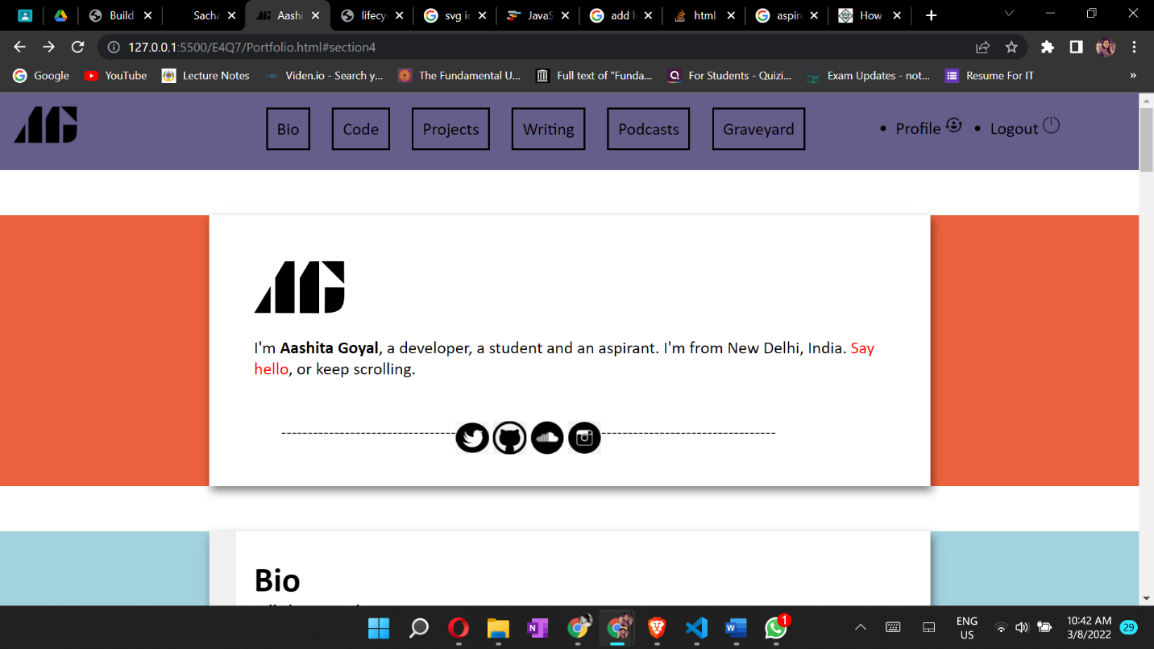

**Exercise 5**

Question 8

***Aim:*** Create a Home Page for Banasthali's Website look like stanford's website.  
<https://www.stanford.edu/>  
  
Menu should be   
About Us | Academics | Research | Campus & Facilities | School Education | Admissions  
  
and top bar should be   
News & Events| International | Careers| Placements |Alumni | Contact Us| Login Hub

***Code:***

**Home.html**

<!DOCTYPE html>

<html>

  <head>

    <title>Aashita Goyal (1913541) Exercise5-Q8</title>

    <link rel="stylesheet" href="./Home.css" />

  </head>

<body>

    <nav class="navbar background" style="background-color:#1c1c1c">

        <ul class="nav-list">

            <li style="margin-left:100px;"><a href="#web" >About Us</a></li>

            <li><a href="#program"> Academics </a></li>

            <li><a href="#course">Research</a></li>

            <li><a href="#course">Campus & Facilities</a></li>

            <li><a href="#course">school</a></li>

            <li><a href="#course"> Education</a></li>

            <li><a href="#course">  Admissions</a></li>

        </ul>

    </nav>

    <nav class="navbar background">

        <ul class="nav-list">

            <div class="logo" style="margin-left:0px;">

                <img src= "https://upload.wikimedia.org/wikipedia/en/e/e9/Banasthali_Vidyapeeth_Logo.png" >

            </div>

            <li style="margin-left:120px;"><a href="#web">News & Events</a></li>

            <li><a href="#program">International </a></li>

            <li><a href="#course">Careers</a></li>

            <li><a href="#course">Placements</a></li>

            <li><a href="#course">Alumni</a></li>

            <li><a href="#course">Contact Us</a></li>

            <!--<li><a href="#course">Login Hub</a></li>-->

        </ul>

        <div class="rightNav">

            <svg xmlns="http://www.w3.org/2000/svg" width="20" height="20" fill="White" class="bi bi-search" viewBox="0 0 16 16">

  <path d="M11.742 10.344a6.5 6.5 0 1 0-1.397 1.398h-.001c.03.04.062.078.098.115l3.85 3.85a1 1 0 0 0 1.415-1.414l-3.85-3.85a1.007 1.007 0 0 0-.115-.1zM12 6.5a5.5 5.5 0 1 1-11 0 5.5 5.5 0 0 1 11 0z"/>

</svg>

    </div>

    <button class="btn btn-sm rightNav " style="Border:none;">Search</button>

    </nav>

<p class="content">BANASTHALI</p>

</body>

<footer class="background">

        <p class="text-footer">

            <button class="btn btn-sm rightNav " style="Border:none;font-size:20px;">Explore Banasthali</button>

    </footer>

</html>

**Home.css**

* {

    margin: 0;

    padding: 0;

    box-sizing: border-box;

  }

  nav{

    position: fixed;

}

 * {

     margin: 0;

     padding: 0;

 }

 .navbar {

     display: flex;

     align-items: center;

     justify-content: center;

     position: sticky;

     top: 0;

     cursor: pointer;

 }

 .background {

     background: black;

     background-blend-mode: darken;

     background-size: cover;

     color: black;

     background: rgba(black, 0.5);

 }

 .nav-list {

     width: 70%;

     display: flex;

     align-items: center;

     color: black;

 }

 .logo {

     display: flex;

     justify-content: center;

     align-items: center;

 }

 .logo {

     width: 180px;

     border-radius: 50px;

     float:left;

 }

 img {

     width: 80px;

     height: 80px;

     border-radius: 50px;

 }

 .nav-list li {

     list-style: none;

     padding: 26px 30px;

 }

 .nav-list li a {

     text-decoration: none;

     color: white;

 }

 .nav-list li a:hover {

     color: grey;

 }

 .rightnav {

     width: 30%;

     text-align: right;

 }

 #search {

     padding: 5px;

     font-size: 17px;

     border: 2px solid grey;

     border-radius: 9px;

 }

 .firstsection {

     background-color: green;

     height: 400px;

 }

 .secondsection {

     background-color: blue;

     height: 400px;

 }

 .box-main {

     display: flex;

     justify-content: center;

     align-items: center;

     color: black;

     max-width: 80%;

     margin: auto;

     height: 80%;

 }

 .firsthalf {

     width: 100%;

     display: flex;

     flex-direction: column;

     justify-content: center;

 }

 .secondhalf {

     width: 30%;

 }

 .secondhalf img {

     width: 70%;

     border: 4px solid white;

     border-radius: 150px;

     display: block;

     margin: auto;

 }

 .text-big {

     font-family: 'Piazzolla', serif;

     font-weight: bold;

     font-size: 35px;

 }

 .text-small {

     font-size: 18px;

 }

 .btn {

     padding: 8px 20px;

     margin: 7px 0;

     border: 2px solid white;

     border-radius: 8px;

     background: none;

     color: white;

     cursor: pointer;

 }

 .btn-sm {

     padding: 6px 10px;

     vertical-align: middle;

 }

 .section {

     height: 400px;

     display: flex;

     align-items: center;

     justify-content: center;

     max-width: 90%;

     margin: auto;

 }

 .section-Left {

     flex-direction: row-reverse;

 }

 .paras {

     padding: 0px 65px;

 }

 .thumbnail img {

     width: 250px;

     border: 2px solid black;

     border-radius: 26px;

     margin-top: 19px;

 }

 .center {

     text-align: center;

 }

 .text-footer {

     text-align: center;

     padding: 30px 0;

     font-family: 'Ubuntu', sans-serif;

     display: flex;

     justify-content: center;

     color: white;

 }

 .navbar1 {

     display: flex;

     background-color: #0eb358;

     font-size: 2rem;

     height: 2.5rem;

 }

 .menu1 {

     margin: 0 3rem;

     justify-content: space-around;

     font-family: 'Franklin Gothic Medium',

         'Arial Narrow',

         Arial, sans-serif;

 }

 .content{

    font-size:100px;

    color:Black;

    background-image: url('https://qph.fs.quoracdn.net/main-qimg-6cafe37ea845b2e15e1af7d49d218a53-lq');

    background-position: center;

    background-repeat: no-repeat;

    background-size: cover;

    padding:500px;

    padding-right: 100px;

    margin:0px;

    font-weight:bold;

    color:white;

 }

***Output:***

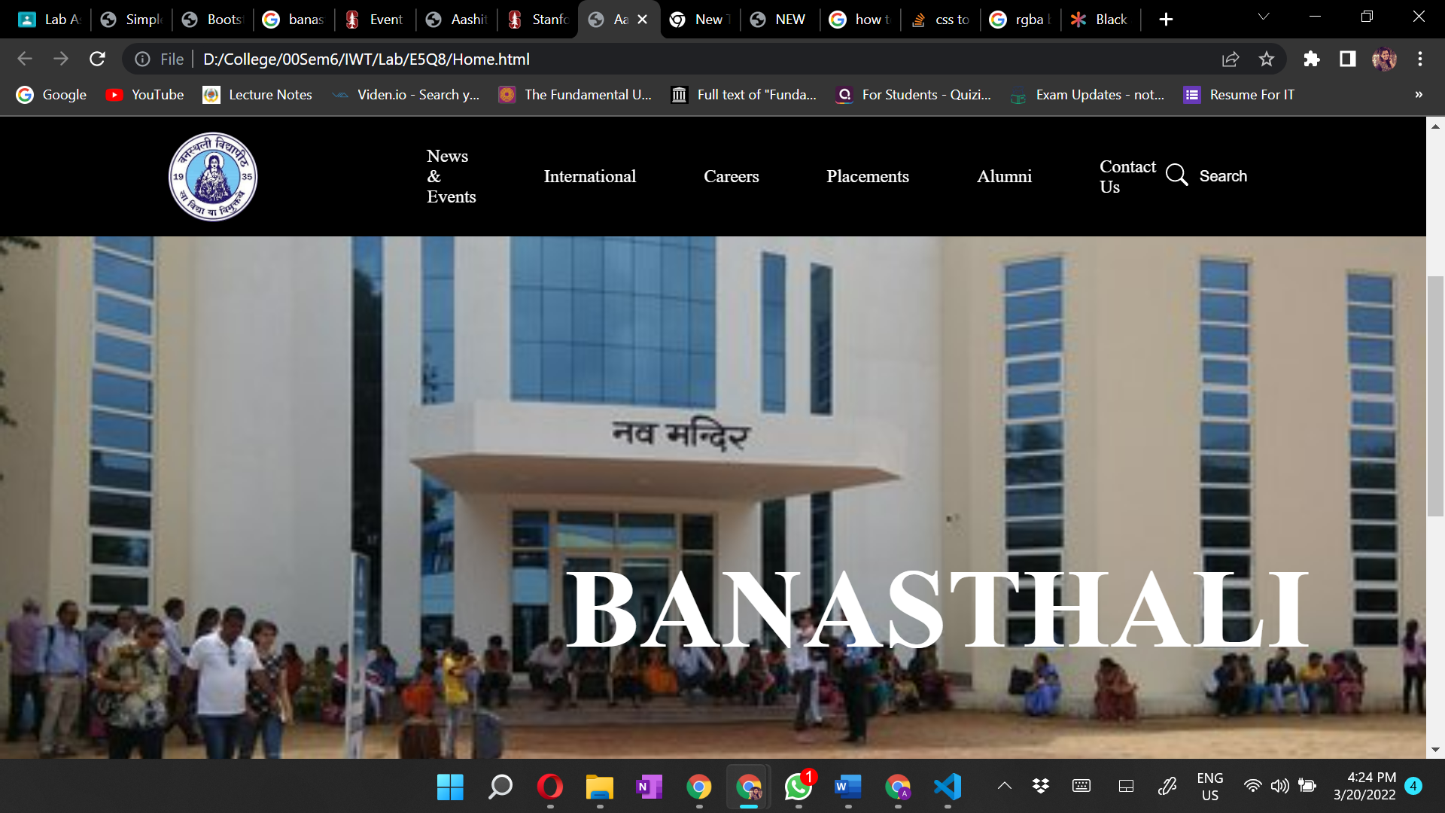

**Exercise 5**

Question 9

***Aim:*** Create an event's page for Banasthali Vidyapith website that look identical to Stanford's events page.

***Code:***

**Event.html**

<!DOCTYPE html>

<html>

  <head>

    <title>Aashita Goyal (1913541) Exercise5-Q9</title>

    <!--<link rel="stylesheet" href="./Event.css" />-->

    <link rel="stylesheet" href="../E5Q8/Home.css"/>

    <meta charset="utf-8">

  <meta name="viewport" content="width=device-width, initial-scale=1">

  <link rel="stylesheet" href="https://maxcdn.bootstrapcdn.com/bootstrap/3.4.1/css/bootstrap.min.css">

  <script src="https://ajax.googleapis.com/ajax/libs/jquery/3.5.1/jquery.min.js"></script>

  <script src="https://maxcdn.bootstrapcdn.com/bootstrap/3.4.1/js/bootstrap.min.js"></script>

</head>

<body>

    <nav class="navbar background" style="background-color:#1c1c1c">

        <ul class="nav-list">

            <li style="margin-left:100px;"><a href="#web" >About Us</a></li>

            <li><a href="#program"> Academics </a></li>

            <li><a href="#course">Research</a></li>

            <li><a href="#course">Campus & Facilities</a></li>

            <li><a href="#course">school</a></li>

            <li><a href="#course"> Education</a></li>

            <li><a href="#course">  Admissions</a></li>

        </ul>

    </nav>

    <nav class="navbar background">

        <ul class="nav-list">

            <div class="logo" style="margin-left:0px;">

                <img src= "https://upload.wikimedia.org/wikipedia/en/e/e9/Banasthali_Vidyapeeth_Logo.png" >

            </div>

            <li style="margin-left:120px;"><a href="#web">News & Events</a></li>

            <li><a href="#program">International </a></li>

            <li><a href="#course">Careers</a></li>

            <li><a href="#course">Placements</a></li>

            <li><a href="#course">Alumni</a></li>

            <li><a href="#course">Contact Us</a></li>

            <!--<li><a href="#course">Login Hub</a></li>-->

        </ul>

        <div class="rightNav">

            <svg xmlns="http://www.w3.org/2000/svg" width="20" height="20" fill="White" class="bi bi-search" viewBox="0 0 16 16">

  <path d="M11.742 10.344a6.5 6.5 0 1 0-1.397 1.398h-.001c.03.04.062.078.098.115l3.85 3.85a1 1 0 0 0 1.415-1.414l-3.85-3.85a1.007 1.007 0 0 0-.115-.1zM12 6.5a5.5 5.5 0 1 1-11 0 5.5 5.5 0 0 1 11 0z"/>

</svg>

    </div>

    <button class="btn btn-sm rightNav " style="Border:none;">Search</button>

    </nav>

<center>

<h1 style="font-weight:bold;font-size:80px;">Event Calendar</h1>

</center><br>

<center>

<h4 style="font-size:40px;">

Upcoming events happening on the Banasthali Vidyapith campus

</h4>

</center><br>

<div class="container">

  <div class="row">

    <div class="col-md-4">

      <div class="thumbnail">

        <a href="https://localist-images.azureedge.net/photos/38574947450014/square_300@2x/bc42c575e40cdef58f9eb712528e713a106d4e80.jpg" target="_blank">

          <!--<img src="https://localist-images.azureedge.net/photos/38574947450014/square_300@2x/bc42c575e40cdef58f9eb712528e713a106d4e80.jpg" alt="Lights" style="width:100%">-->

          <img src="https://www.uttarakhandmirror.com/wp-content/uploads/2021/04/Banasthali-Vidyapith-University-Result-2021.jpg"

          alt="Lights" style="width:100%">

          <div class="caption">

          <a href="" >

Exquisite Reality: Photography and the Invention of Nationhood, 1851-1900 [VIRTUAL]  </a>

            <p>EXHIBITION</p>

          </div>

        </a>

      </div>

    </div>

    <div class="col-md-4">

      <div class="thumbnail">

        <a href="https://localist-images.azureedge.net/photos/38574945719380/square_300@2x/1338d497cd2a334e576defd1efcaa1e0d3740ede.jpg" target="_blank">

          <!-- <img src="https://localist-images.azureedge.net/photos/38574945719380/square_300@2x/1338d497cd2a334e576defd1efcaa1e0d3740ede.jpg" alt="Nature" style="width:100%"> -->

          <img src="https://images.shiksha.com/mediadata/images/1531983000phpovfCSF.jpeg"

          alt="Lights" style="width:100%">

          <div class="caption">

          <a href="" >

Say Their Names - No More Names   </a>

            <p>EXHIBITION</p>

          </div>

        </a>

      </div>

    </div>

    <div class="col-md-4">

      <div class="thumbnail">

        <a href="https://localist-images.azureedge.net/photos/38649499673041/square_300/8566616376191c7ee2ed236e8fda58f48fec5197.jpg" target="_blank">

          <!-- <img src="https://localist-images.azureedge.net/photos/38649499673041/square_300/8566616376191c7ee2ed236e8fda58f48fec5197.jpg" alt="Fjords" style="width:100%"> -->

          <img src="https://indywp.com/wp-content/uploads/2019/06/bn.jpg"

          alt="Lights" style="width:100%">

          <div class="caption">

          <a href="" >

Feminist History: A Conference in Honor of Estelle Freedman </a>

            <p>CONFERENCE/SYMPOSIUM</p>

          </div>

        </a>

      </div>

    </div>

    <div class="col-md-4">

      <div class="thumbnail">

        <a href="https://localist-images.azureedge.net/photos/39264792727972/square_300@2x/dfef2e3e5673c6dc3ad359e654bb945fb5da73bd.jpg" target="_blank">

          <img src="https://localist-images.azureedge.net/photos/39264792727972/square_300@2x/dfef2e3e5673c6dc3ad359e654bb945fb5da73bd.jpg" alt="Lights" style="width:100%">

          <div class="caption">

          <a href="" >

Another Modernity with Clémence Boulouque</a>

            <p>LECTURE/PRESENTATION/TALK</p>

          </div>

        </a>

      </div>

    </div>

    <div class="col-md-4">

      <div class="thumbnail">

        <a href="https://localist-images.azureedge.net/photos/39318257231538/square_300@2x/05438e3a19b73d6d80138e8012d27b676c9396fa.jpg" target="_blank">

          <img src="https://localist-images.azureedge.net/photos/39318257231538/square_300@2x/05438e3a19b73d6d80138e8012d27b676c9396fa.jpg" alt="Lights" style="width:100%">

          <div class="caption">

          <a href="" >

Cadre Country: How China became the Chinese Communist Party  </a>

            <p>LECTURE/PRESENTATION/TALK</p>

          </div>

        </a>

      </div>

    </div>

    <div class="col-md-4">

      <div class="thumbnail">

        <a href="https://localist-images.azureedge.net/photos/39324449836976/square_300/ef30e6394e07ac79c2a1d5600be8a933b8074dee.jpg" target="_blank">

          <img src="https://localist-images.azureedge.net/photos/39324449836976/square_300/ef30e6394e07ac79c2a1d5600be8a933b8074dee.jpg" alt="Lights" style="width:100%">

          <div class="caption">

          <a href="" >

Mother Nature, Bioweapons and Lab Accidents: Guarding Against the Next Global Biological Catastrophe   </a>

            <p>LECTURE/PRESENTATION/TALK</p>

          </div>

        </a>

      </div>

    </div>

  </div>

</div>

<center ><button type="button" style="padding:20px;margin:10px;Background-color:#960000;font-size:30px;

color:white;font-weight:bold;margin-bottom:45px;">More Banasthali Events</button>

</center>

<div class="footer-tag" style="padding:50px;margin:20px;width:100%;">

<img src="https://i.pinimg.com/originals/ca/3b/f0/ca3bf05cfab74677e5b73b130bd30991.png " style="float:right;padding:5px;margin:5px;width:100px;height:100px;">

<img src="https://cdn-icons-png.flaticon.com/512/60/60580.png " style="float:right;padding:5px;margin:5px;width:90px;height:90px;">

<img src="https://freepngimg.com/download/logo/69813-instagram-logo-computer-royalty-free-icons-free-download-png-hq.png" style="float:right;padding:5px;margin:5px;width:100px;height:100px;">

<img src=" https://rachelliv.com/wp-content/uploads/2020/08/black-youtube-logo-logodix-black-youtube-logo-500_500.png" style="float:right;padding:5px;margin:5px;width:100px;height:100px;">

<img src=" https://upload.wikimedia.org/wikipedia/commons/thumb/f/fa/Apple_logo_black.svg/1667px-Apple_logo_black.svg.png" style="float:right;padding:5px;margin:5px;width:90px;height:90px;">

</div><br><br><br>

<footer>

            <div class="column">

<h5 style="color:#960000;">Company</h5>

                <ul style="list-style-type:disc">

                    <li><a href="">About Us</li></a>

                    <li><a href="">Careers</li></a>

                    <li><a href="">Privacy Policy</li></a>

                    <li><a href="">Contact Us</li></a>

                </ul>

            </div>

            <div class="column">

<h5 style="color:#960000;">Learn</h5>

                <ul>

                    <li><a href="">Algorithms</li></a>

                    <li><a href="">Data Structures</li></a>

                    <li><a href="">Languages</li>

                    <li><a href="">CS Subjects</li></a><a href="">

                    <li><a href="">Video Tutorials</li></a>

                </ul>

            </div>

            <div class="column">

<h5 style="color:#960000;">Practice</h5>

                <ul>

                    <li><a href="">Company-wise</li></a>

                    <li><a href="">Topic-wise</li></a>

                    <li><a href="">Contests</li></a>

                    <li><a href="">Subjective Ques</a>tions</li></a>

                </ul>

            </div>

            <div class="column">

            <h5 style="color:#960000;">Research</h5>

                <ul>

                    <li><a href="">Company-wise</li></a>

                    <li><a href="">Topic-wise</li></a>

                    <li><a href="">Contests</li></a>

                    <li><a href="">Subjective Questions</li></a>

                </ul>

            </div>

            <div class="column">

            <h5  style="color:#960000;">Resources</h5>

                <ul>

                    <li><a href="">Company-wise</li></a>

                    <li><a href="">Topic-wise</li></a>

                    <li><a href="">Contests</li></a>

                    <li><a href="">Subjective Questions</li></a>

                </ul>

            </div>

        </footer>

        <!--HTML figcaption tag ends here-->

</body>

<!-- Footer Menu -->

    <footer id="footer" style="margin-top:600px;">

        <!-- Company Details -->

        <!-- 1. Address

        2. Contact Number

        3. Enquiry Mail

      -->

        <div style="float: left;">

        <a href=" " ><img src=" https://www.lawof.in/wp-content/uploads/2019/10/banasthali_3040813_835x547-m.jpg"        style="width:150px;height:150px;"></a>

        </div>

        <div class="company-details"  style="float: right;margin-top:40px;">

            <div class="row">

                <div id="col1">

                    <span id="icon" class="fa fa-map-marker" style="color:white;"></span>

                    <span style="color:white;">

                    710-B, Advant Navis Business Park,

                    <br />Sector-142, Noida

                </span>

                </div>

                <div id="col2">

                    <span id="icon" class="fa fa-phone"></span>

                    <span style="color:white;">

                    Telephone: +91-890 * * * * * * *

                </span>

                </div>

                <div id="col3">

                    <span id="icon" class="fa fa-envelope"></span>

                    <span  style="color:white;">xyz@geeksforgeeks.org</span>

                </div>

            </div>

        </div>

        <!-- Copyright Section -->

        <div class="copyright">

        </div>

    </footer>

</body>

</html>

**Event.css**

* {

    margin: 0;

    padding: 0;

    box-sizing: border-box;

  }

   nav{

           position: fixed;

    }

        * {

            margin: 0;

            padding: 0;

        }

        .navbar {

            display: flex;

            align-items: center;

            justify-content: center;

            position: sticky;

            top: 0;

            cursor: pointer;

        }

        .background {

            background: #960000;

            background-blend-mode: darken;

            background-size: cover;

        }

        .nav-list {

            width: 70%;

            display: flex;

            align-items: center;

        }

        .logo {

            display: flex;

            justify-content: center;

            align-items: center;

        }

        .logo {

            width: 180px;

            border-radius: 50px;

            float:left;

        }

        img {

            width: 80px;

            height: 80px;

            border-radius: 50px;

        }

        .nav-list li {

            list-style: none;

            padding: 26px 30px;

        }

        .nav-list li a {

            text-decoration: none;

            color: white;

        }

        .nav-list li a:hover {

            color: grey;

        }

        .rightnav {

            width: 30%;

            text-align: right;

        }

        #search {

            padding: 5px;

            font-size: 17px;

            border: 2px solid grey;

            border-radius: 9px;

        }

        .firstsection {

            background-color: green;

            height: 400px;

        }

        .secondsection {

            background-color: blue;

            height: 400px;

        }

        .box-main {

            display: flex;

            justify-content: center;

            align-items: center;

            color: black;

            max-width: 80%;

            margin: auto;

            height: 80%;

        }

        .firsthalf {

            width: 100%;

            display: flex;

            flex-direction: column;

            justify-content: center;

        }

        .secondhalf {

            width: 30%;

        }

        .secondhalf img {

            width: 70%;

            border: 4px solid white;

            border-radius: 150px;

            display: block;

            margin: auto;

        }

        .text-big {

            font-family: 'Piazzolla', serif;

            font-weight: bold;

            font-size: 35px;

        }

        .text-small {

            font-size: 18px;

        }

        .btn {

            padding: 8px 20px;

            margin: 7px 0;

            border: 2px solid white;

            border-radius: 8px;

            background: none;

            color: white;

            cursor: pointer;

        }

        .btn-sm {

            padding: 6px 10px;

            vertical-align: middle;

        }

        .section {

            height: 400px;

            display: flex;

            align-items: center;

            justify-content: center;

            max-width: 90%;

            margin: auto;

        }

        .section-Left {

            flex-direction: row-reverse;

        }

        .paras {

            padding: 0px 65px;

        }

        .thumbnail img {

            width: 250px;

            border: 2px solid black;

            border-radius: 26px;

            margin-top: 19px;

        }

        .center {

            text-align: center;

        }

        .text-footer {

            text-align: center;

            padding: 30px 0;

            font-family: 'Ubuntu', sans-serif;

            display: flex;

            justify-content: center;

            color: white;

        }

        .navbar1 {

            display: flex;

            background-color: #0eb358;

            font-size: 2rem;

            height: 2.5rem;

        }

        .menu1 {

            margin: 0 3rem;

            justify-content: space-around;

            font-family: 'Franklin Gothic Medium',

                'Arial Narrow',

                Arial, sans-serif;

        }

        .column {

                float: left;

                width: 27%;

               height: 300px;

            }

            h5 {

                font-size:20px;

                font-weight:bold;

            }

 #footer {

            position: fixed;

            padding: 10px 10px 0px 10px;

            bottom:0%;

            width: 100%;

            /* Height of the footer*/

            height: 150px;

            background:  #960000;

        }

***Output:***

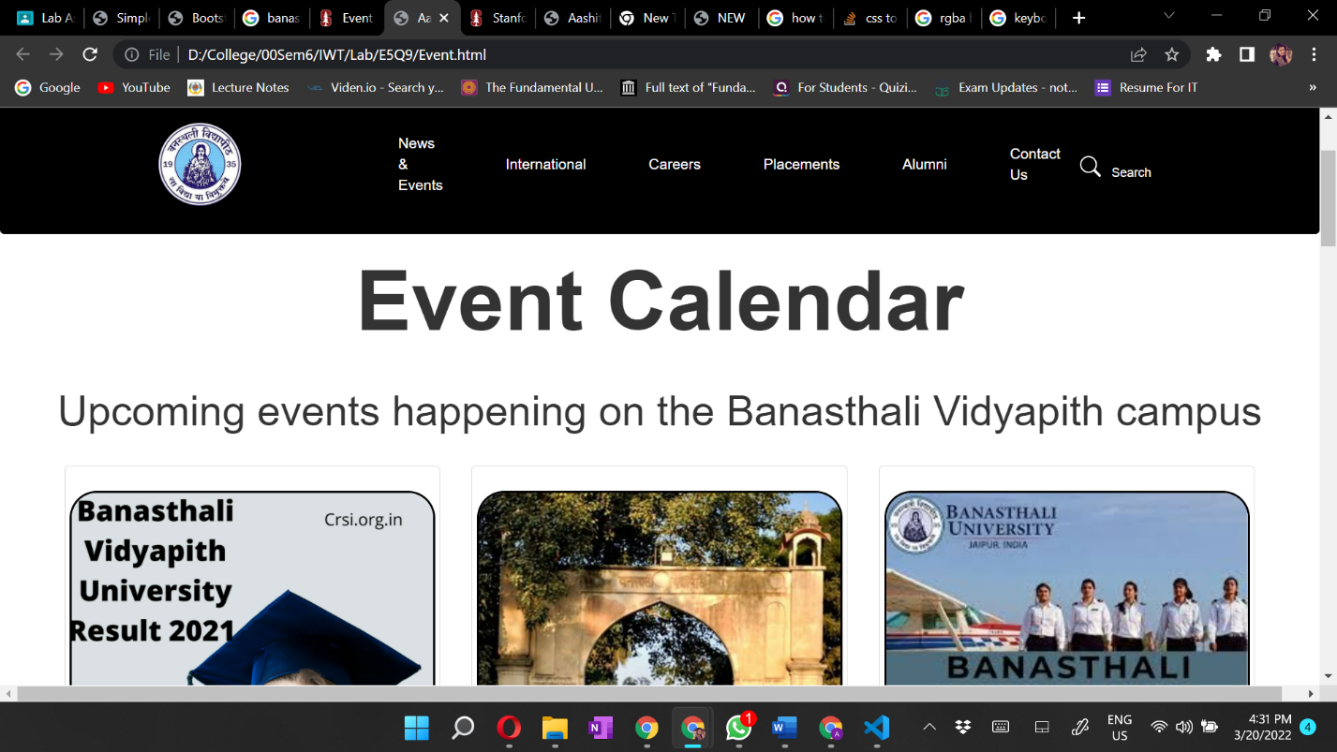

**Exercise 6**

Question 10

***Aim:*** Create a Web page that accept a value in a text box for temperature in one unit and convert it to another. It should accept input in kelvin, Celsius, Fahrenheit and Convert accordingly.

***Code:***

**Temp.html**

<!DOCTYPE html>

<html>

  <head>

    <title>Aashita Goyal (1913541) Exercise6-Q10</title>

    <link rel="stylesheet" href="./Temp.css">

  </head>

  <body>

    <div class="wrapper">

        <div class="card">

            <h1>Temperature Converter</h1>

            <p><strong>Enter temperature in any of the following units and obtain conversion of the same value into other two units.</strong> </p>

            <div class="temp-box">

                <div class="temp-fields">

                    <h3 class="spacing">Celsius</h3>

                    <input id="celsius" value="0"/>

                </div>

                <div class="temp-fields">

                    <h3 class="spacing">Fahrenheit</h3>

                    <input id="fahrenheit" value="0"/>

                </div>

                <div class="temp-fields">

                    <h3 class="spacing">Kelvin</h3>

                    <input id="kelvin" value="0"/>

                </div>

            </div>

            <div class="buttons">

                <button id="submit" class="spacing" type="submit" value="submit">Convert</button>

                <button id="reset" class="spacing" type="reset" value="reset">Reset</button>

            </div>

        </div>

    </div>

      <script src="./Temp.js"></script>

  </body>

</html>

**Temp.css**

* {

    margin: 0;

    padding: 0;

    box-sizing: border-box;

  }

  h1{

      color: firebrick;

      padding: 20px;

      text-align: center;

  }

  .temp-fields{

      text-align: center;

  }

  .buttons{

      margin-left: 580px;

      margin-top: 40px;

  }

  .temp-box{

      border-color: black;

      background-color: yellowgreen;

      width: 500px;

      margin-left: 380px;

      height: 280px;

  }

  .temp-fields{

      padding-top: 30px;

  }

  p{

      text-align: center;

      padding-bottom: 20px;

      background-color: silver;

      width: 800px;

      margin-left: 250px;

      padding-top: 15px;

      font-size: larger;

      margin-bottom: 30px;

  }

**Temp.js**

var lastEdited = "celsius";  // initialize the lastEdited flag to any of the three input fields.

//button listeners

document.getElementById("submit").onclick = convert;

document.getElementById("reset").onclick = reset;

//picks up on if and when an input field changes, then sets the lastEdited flag to the input field that was changed.

document.getElementById("celsius").onchange = function() {

  lastEdited = "celsius";

};

document.getElementById("fahrenheit").onchange = function() {

  lastEdited = "fahrenheit";

};

document.getElementById("kelvin").onchange = function() {

  lastEdited = "kelvin";

};

function convert(temp) {

  //initialize local variables

  var celsius = document.getElementById("celsius").value;

  celsius = parseFloat(celsius);

  var fahrenheit = document.getElementById("fahrenheit").value;

  fahrenheit = parseFloat(fahrenheit);

  var kelvin = document.getElementById("kelvin").value;

  kelvin = parseFloat(kelvin);

  //temp values

  var conversionC;

  var conversionF;

  var conversionK;

  //if the celsius field changes, convert the fahrenheit and kelvin values

  if (lastEdited === "celsius") {

    conversionF = celsius * 9 / 5 + 32;

    conversionK = celsius + 273;

    //round the converted fahrenheit and kelvin values

    document.getElementById("fahrenheit").value = Math.round(conversionF);

    document.getElementById("kelvin").value = Math.round(conversionK);

  }

    //if the fahrenheit field changes, convert the celsius and kelvin values

    else if (lastEdited === "fahrenheit") {

    conversionC = (fahrenheit - 32) * 5 / 9;

    conversionK = conversionC + 273;

    //round the converted celsius and kelvin values

    document.getElementById("celsius").value = Math.round(conversionC);

    document.getElementById("kelvin").value = Math.round(conversionK);

  }

    //if the kelvin field changes, convert the celsius and fahrenheit values

    else if (lastEdited === "kelvin") {

    conversionC = kelvin - 273;

    conversionF = conversionC * 9 / 5 + 32;

    //round the converted celsius and fahrenheit values

    document.getElementById("celsius").value = Math.round(conversionC);

    document.getElementById("fahrenheit").value = Math.round(conversionF);

  }

  //get the current conversion temp values and store them in the input fields

  document.getElementById("celsius").innerHTML = conversionC;

  document.getElementById("fahrenheit").innerHTML = conversionF;

  document.getElementById("kelvin").innerHTML = conversionK;

}

//reset function for the reset button to reset all current values

function reset() {

  document.getElementById("celsius").value = 0;

  document.getElementById("fahrenheit").value = 0;

  document.getElementById("kelvin").value = 0;

}

***Output:***

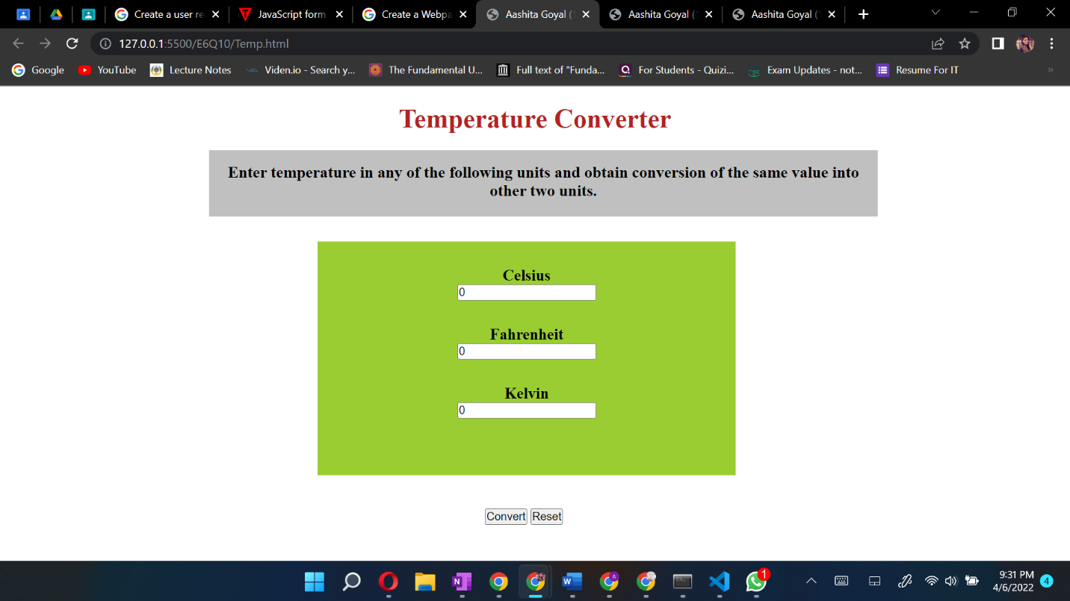

Question 11

***Aim:*** Create a Webpage with two buttons start and stop. When user click on start button a timer should start to count seconds. When a user click on stop button then it should stop.

***Code:***

**Timer.html**

<!DOCTYPE html>

<html>

  <head>

    <title>Aashita Goyal (1913541) Exercise6-Q11</title>

    <link rel="stylesheet" href="./Timer.css">

    <script src="https://ajax.googleapis.com/ajax/libs/jquery/3.2.1/jquery.min.js"></script>

  </head>

  <body>

    <center>

        <h1>TIMER</h1>

        <div id="timer">

          <span id="hours">00:</span>

          <span id="mins">00:</span>

          <span id="seconds">00</span>

        </div>

        <div id="controls">

        <button id="start">Start</button>

        <button id="stop">Stop</button>

        </div>

      </center>

    <script src="./Timer.js"></script>

  </body>

</html>

**Timer.css**

* {

    margin: 0;

    padding: 0;

    box-sizing: border-box;

  }

#timer {

    font-size:150px;

    margin:0 auto;

    width:800px;

    background-color: darkgrey;

    border-radius: 500px;

    margin-bottom: 50px;

  }

  #controls {

    margin:0 auto;

    width:600px;

  }

  #controls button {

    font-size:24px;

  }

**Timer.js**

var hours =0;

var mins =0;

var seconds =0;

$('#start').click(function(){

      startTimer();

});

$('#stop').click(function(){

      clearTimeout(timex);

});

$('#reset').click(function(){

      hours =0;      mins =0;      seconds =0;

  $('#hours','#mins').html('00');

  $('#seconds').html('00');

});

function startTimer(){

  timex = setTimeout(function(){

      seconds++;

    if(seconds >59){seconds=0;mins++;

       if(mins>59) {

       mins=0;hours++;

         if(hours <10) {$("#hours").text('0'+hours+':')} else $("#hours").text(hours+':');

        }

    if(mins<10){

      $("#mins").text('0'+mins+':');}

       else $("#mins").text(mins+':');

                   }

    if(seconds <10) {

      $("#seconds").text('0'+seconds);} else {

      $("#seconds").text(seconds);

      }

      startTimer();

  },1000);

}

***Output:***

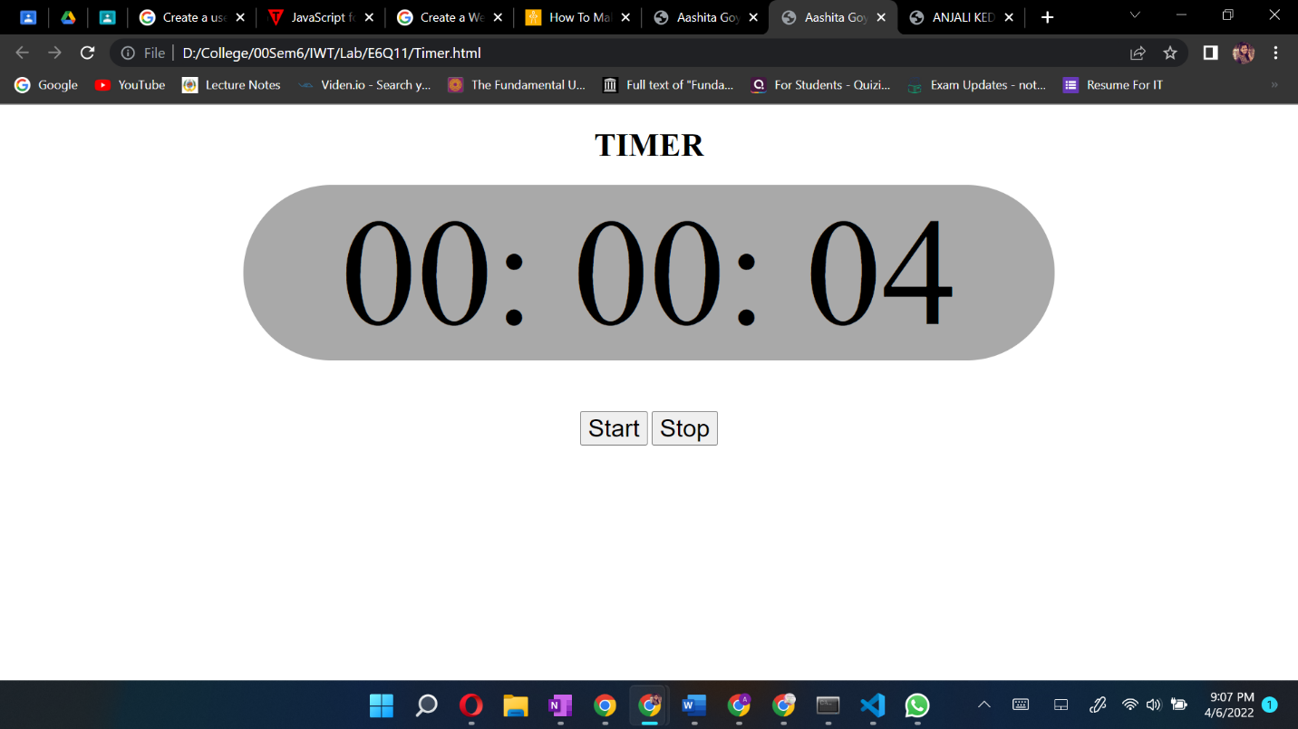

Question 12

***Aim:*** Create a Webpage to display digital clock that display updated time of your system without refreshing webpage.

***Code:***

**Clock.html**

<!DOCTYPE html>

<html>

  <head>

    <title>Aashita Goyal (1913541) Exercise6-Q</title>

    <link rel="stylesheet" href="./Clock.css">

  </head>

  <body>

    <h1>Digital Clock</h1>

    <div id="digClock"></div>

    <script src="./Clock.js"></script>

  </body>

</html>

**Clock.css**

* {

    margin: 0;

    padding: 0;

    box-sizing: border-box;

  }

  body{

      background-color: black;

  }

  #digClock {

    font-size: 90px;

    width: 400px;

    text-align: center;

    background-color: darkslategray;

    color: darkgray;

    margin-left: 450px;

    margin-top: 5px;

}

h1{

    margin-left: 490px;

    padding: 20px;

    font-size: 50px;

    margin-top: 150px;

    color: grey;

}

**Clock.js**

function showTime() {

    let time = new Date();

    let hour = time.getHours();

    let min = time.getMinutes();

    let sec = time.getSeconds();

    if (hour > 12) {

        hour -= 12;

    }

    if (hour == 0) {

        hr = 12;

    }

    hour = hour < 10 ? "0" + hour : hour;

    min = min < 10 ? "0" + min : min;

    sec = sec < 10 ? "0" + sec : sec;

    let currentTime = hour + ":"

        + min + ":" + sec;

    document.getElementById("digClock")

        .innerHTML = currentTime;

}

setInterval(showTime, 1000);

showTime();

***Output:***

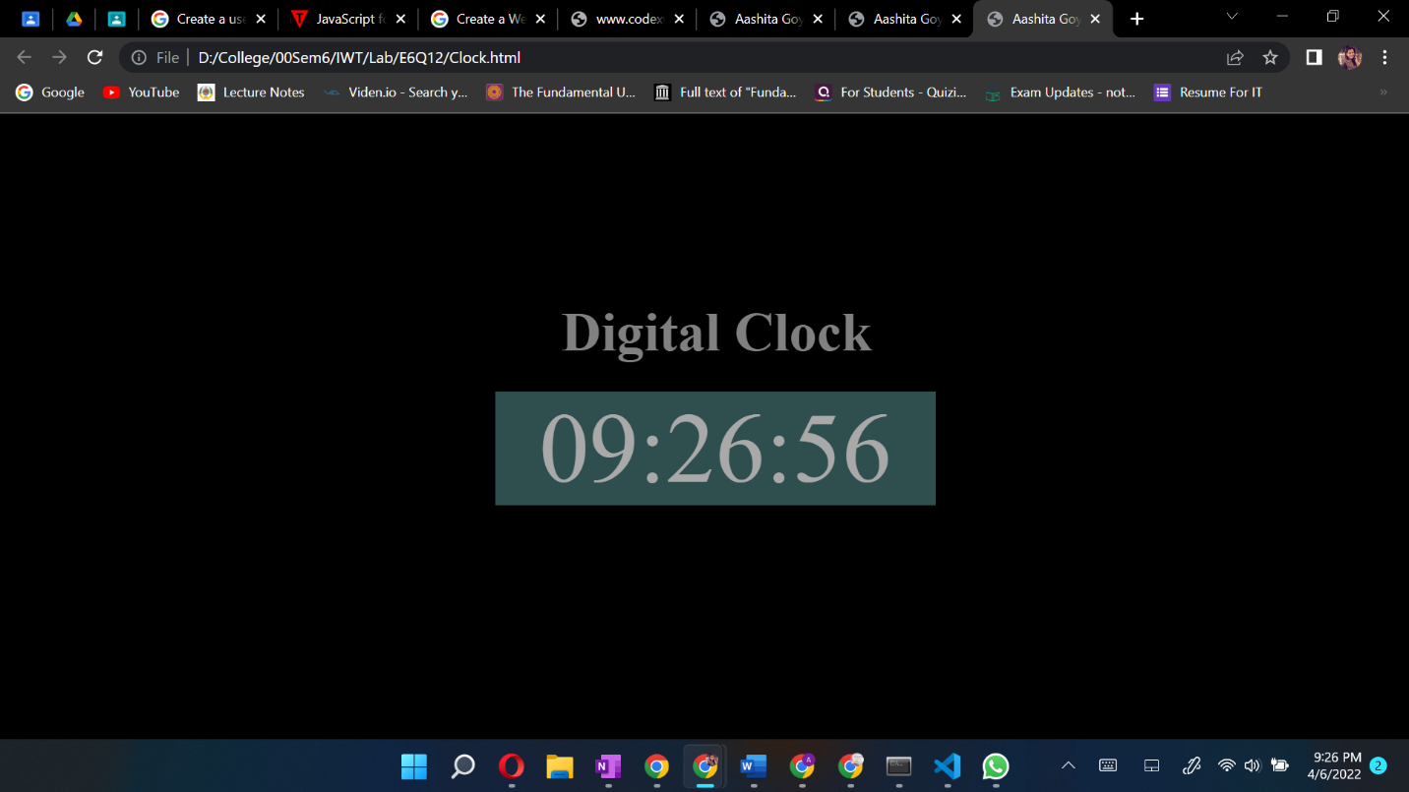

Question 13

***Aim:*** Write a JavaScript to display greeting message according to time with user name that is accessing the webpage. When user clicks on the greeting message it should hide.

***Code:***

**Greet.html**

<!DOCTYPE html>

<html>

  <head>

    <title>Aashita Goyal (1913541) Exercise6-Q13</title>

    <link rel="stylesheet" href="./Greet.css">

  </head>

  <body>

    <div class="box">

      <h1 id="para" onclick="greetings()"></h1>

      <div id="digClock"></div>

    </div>

      <script src="./Greet.js"></script>

  </body>

</html>

**Greet.css**

* {

    margin: 0;

    padding: 0;

    box-sizing: border-box;

  }

  body{

    background-color: darkolivegreen;

  }

  #para{

    text-align: center;

    padding: 20px;

    margin-top: 30px;

    font-size: 60px;

    color: darkkhaki;

  }

  #digClock{

    text-align: center;

    padding: 10px;

    font-size: 30px;

    color: darkkhaki;

  }

  .box{

    background-color: black;

    width: 500px;

    margin-left: 410px;

  }

**Greet.js**

let fname = window.prompt("Enter your full name");

var now = new Date();

var hour = now.getHours();

greet = document.getElementById('para');

greet.addEventListener('click',function run()

{

    greet.style.display='none';

})

if(hour >= 6 && hour < 12)

{

    greet.innerHTML = "Good Morning "+fname +"The time is: ";

}

else if(hour == 12)

{

    greet.innerHTML = "Good Noon "+fname;

}

else if(hour >= 12 && hour <= 17)

{

    greet.innerHTML = "Good Afternoon "+fname;

}

else if (hour >= 18 && hour <= 21) {

    greet.innerHTML = "Good Evening "+fname;

}

else

{

    greet.innerHTML = "Good Night "+fname;

}

function showTime() {

    let time = new Date();

    let hour = time.getHours();

    let min = time.getMinutes();

    let sec = time.getSeconds();

    if (hour > 12) {

        hour -= 12;

    }

    if (hour == 0) {

        hr = 12;

    }

    hour = hour < 10 ? "0" + hour : hour;

    min = min < 10 ? "0" + min : min;

    sec = sec < 10 ? "0" + sec : sec;

    let currentTime = hour + ":"

        + min + ":" + sec;

    document.getElementById("digClock")

        .innerHTML = "The time is "+currentTime;

}

setInterval(showTime, 1000);

showTime();

***Output:***

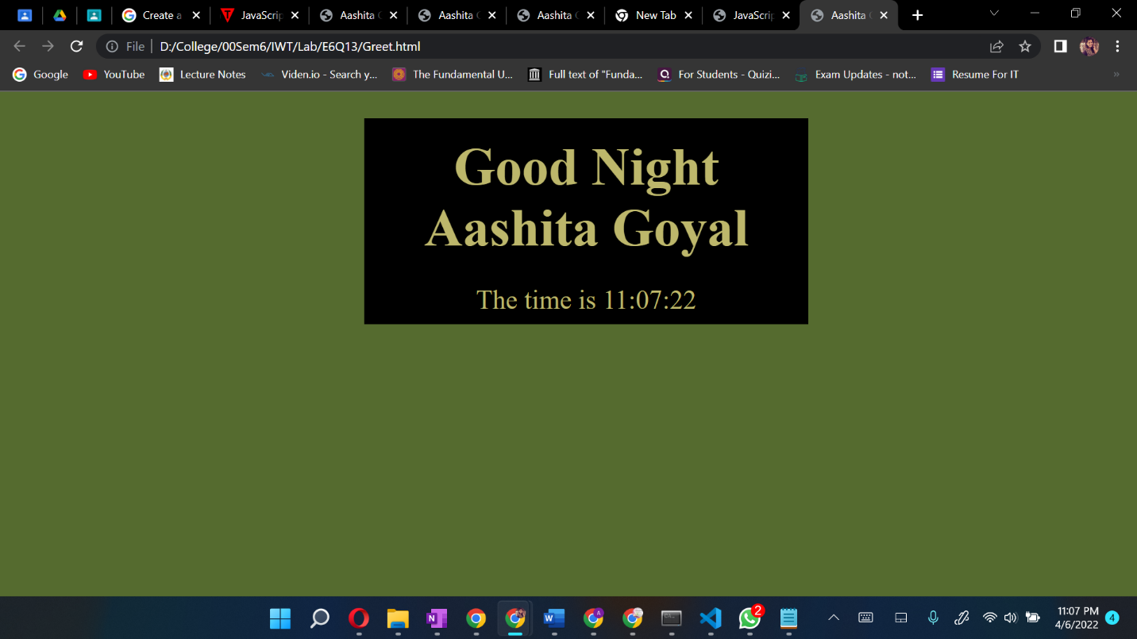

Question 14

***Aim:*** Create a user registration form which accepts first name, last name, user ID, password, confirm password, Address, Email ID, Contact number. Apply appropriate client side validations using JavaScript for all fields of html form. Also format this form using a CSS

***Code:***

**Form_Validation.html**

<!DOCTYPE html>

<html>

  <head>

    <title>Aashita Goyal (1913541) Exercise6-Q14</title>

    <link rel="stylesheet" href="./Form_Validation.css">

  </head>

    <body onload="document.registration.userid.focus();">

      <h1>Registration Form</h1>

      <div class="box">

      <form name='registration' onSubmit="return formValidation();">

      <ul>

          <li><label for="userid">First Name:</label></li>

      <li><input type="text" name="userid" size="12" /></li>

      <li><label for="userid">Last Name:</label></li>

      <li><input type="text" name="userid" size="12" /></li>

      <li><label for="passid">Password:</label></li>

      <li><input type="password" name="passid" size="12" /></li>

      <li><label for="passid" id="label_length">Confirm Password:</label></li>

      <li><input type="password" name="passid" size="12" /></li>

      <li><label for="address">Address:</label></li>

      <li><input type="text" name="address" size="50" /></li>

      <li><label for="email">Email:</label></li>

      <li><input type="email" name="email" size="50" /></li>

      <li><label for="phone">Contact No:</label></li>

      <li><input type="text" name="number" /></li>

      <li><input type="submit" name="submit" value="Submit" /></li>

      </ul>

      </form>

    </div>

      <script src="./Form_Validation.js"></script>

  </body>

</html>

<

**Form_Validation.css**

* {

    margin: 0;

    padding: 0;

    box-sizing: border-box;

  }

  body{

    background-color: darkgray;

  }

  form{

    text-align: center;

    font-size: 30px;

  }

  label{

    width: 100px;

  }

  #label_length{

  width: fit-content;

  }

  .box{

    margin-left: 500px;

    padding-top: 30px;

  }

  h1 {

    margin-left: 70px;

    text-align: center;

    padding: 10px;

    margin-top: 20px;

    }

    form li {

    list-style: none;

    margin-bottom: 5px;

    margin: 10px;

    }

    form ul li label{

    float: left;

    clear: left;

    width: 100px;

    text-align: right;

    margin-right: 10px;

    font-family:Verdana, Arial, Helvetica, sans-serif;

    font-size:14px;

    }

    form ul li input, select, span {

    float: left;

    margin-bottom: 10px;

    }

    form textarea {

    float: left;

    width: 350px;

    height: 150px;

    }

    [type="submit"] {

    clear: left;

    margin: 20px 0 0 230px;

    font-size:18px

    }

    p {

    margin-left: 70px;

    font-weight: bold;

    }

**Form_Validation.js**

function formValidation()

{

var uid = document.registration.userid;

var passid = document.registration.passid;

var uname = document.registration.username;

var uadd = document.registration.address;

var uphone = document.registration.phone;

var uemail = document.registration.email;

var fname = document.reg_form.fname;

var lname = document.reg_form.lname;

if(userid_validation(uid,5,12))

{

if(passid_validation(passid,7,12))

{

if(allLetter(uname))

{

if(alphanumeric(uadd))

{

if(allnumeric(uphone))

{

if(ValidateEmail(uemail))

{

}

}

}

}

}

}

return false;

}

function userid_validation(uid,mx,my)

{

var uid_len = uid.value.length;

if (uid_len == 0 || uid_len >= my || uid_len < mx)

{

alert("User Id should not be empty / length be between "+mx+" to "+my);

uid.focus();

return false;

}

return true;

}

function passid_validation(passid,mx,my)

{

var passid_len = passid.value.length;

if (passid_len == 0 ||passid_len >= my || passid_len < mx)

{

alert("Password should not be empty / length be between "+mx+" to "+my);

passid.focus();

return false;

}

return true;

}

function allLetter(uname)

{

var letters = /^[A-Za-z]+$/;

if(uname.value.match(letters))

{

return true;

}

else

{

alert('Username must have alphabet characters only');

uname.focus();

return false;

}

}

function alphanumeric(uadd)

{

var letters = /^[0-9a-zA-Z]+$/;

if(uadd.value.match(letters))

{

return true;

}

else

{

alert('User address must have alphanumeric characters only');

uadd.focus();

return false;

}

}

function allnumeric(uphone)

{

var numbers = /^[0-9]+$/;

if(uphone.value.match(numbers))

{

return true;

}

else

{

alert('phone code must have numeric characters only');

uzip.focus();

return false;

}

}

function ValidateEmail(uemail)

{

var mailformat = /^\w+([\.-]?\w+)@\w+([\.-]?\w+)(\.\w{2,3})+$/;

if(uemail.value.match(mailformat))

{

return true;

}

else

{

alert("You have entered an invalid email address!");

uemail.focus();

return false;

}

if (fname.value.length <= 0) {

 alert("Name is required");

 fname.focus();

 return false;

 }

 if (lname.value.length <= 0) {

 alert("Last Name is required");

 lname.focus();

 return false;

 }

else

{

alert('Form Succesfully Submitted');

window.location.reload()

return true;

}

}

***Output:***

